Jericho Captured & Rahab Saved
Key Verse:
“By faith the walls of Jericho fell, after the people had marched around them for seven days.”
Hebrews 11:30

Read Joshua 5-13-15; 6:1-27
and Hebrews 11:30-31
Last month we heard how the two spies returned from Jericho with the news that everyone in the city was terrified of them. Joshua, you’ll remember, was encouraged that God would give them the city in a mighty victory. For the next few days, Joshua reminded the Jews again of God’s special instructions to them. They were not to be like the heathen in the land, nor to worship their idols; they were to be known as God’s own people.
Shortly after, Joshua was out scouting round the city, looking up at its forbidding walls, and perhaps wondering how God would give them such a great city. Suddenly he saw a Man with a sword in his hand standing nearby! Joshua bravely challenged him, “Are you for us, or for our enemies?” The answer came back clearly. “I am come as the Commander of the Army of the Lord! Take off your shoes for you are standing on holy ground!”
Instantly, Joshua recognised this was the Angel of the Lord, come to fight for Israel! He bowed and worshipped Him, with his face to the ground. Then the Captain of the Lord’s Army gave Joshua a comforting promise. “I have given into your hand Jericho, and the King and the mighty men.” He went on to tell Joshua exactly what to do to win the city of Jericho, but with unusual instructions. I’m sure Joshua had never had military instructions like these ones before!
“All the army must march once around the city, every day for six days. The High Priests must carry the Ark at the head of the procession, and blow their ‘shofars’ (special rams’ horn trumpets).

1. How were the Children of Israel to be different from others?
2. How did the ‘Man with the sword’ describe himself?
3. What great promise was given to Joshua?
4. What was required for this great victory to happen?
5. (a) Who were saved out of Jericho? (b) How can we be saved?
My Name is _____________________________________________ Age ___________
Level 3 lesson 1
Extra: What lessons about obedience can you see from this story?
Level 4 lesson 21
QUESTIONS & ANSWERS
Key Verse:
“Jesus said, ‘I tell you the truth, unless a man is born again, he cannot see the kingdom of God.’”
John 3:3
On the seventh day, you must circle the city seven times. When the priests blow a long blast on the trumpets, all the people must shout together with a great shout, and the walls will fall down flat! Then all the people must enter the city, every man straight before him.”
Joshua returned to camp and gave the people the instructions of the Lord. Although perhaps wondering at the strange commands, the people obeyed the Lord’s words exactly. Imagine how terrified the people of Jericho must have felt as they watched these strange tactics. Only in one home was there quietness and peace: Rahab’s. The scarlet cord in her window reminded her continually of her safety and coming deliverance.
Before dawn on the seventh day the Israelites were up and ready to march. This was THE day God was going to demolish the walls of Jericho! Six times they marched around in total silence, except for the priests blowing on their trumpets. Then after the seventh time, the priests blew a long blast on the trumpets, and with a mighty SHOUT from the Israelites, the walls of that great city fell with a mighty crash. They were no match for the power of Almighty God! The Israelites rushed in and conquered the city, sparing only Rahab and her family, just as the spies had promised her.
What a lesson for us in this story! Obedience to God’s Word brings salvation and deliverance. God has said that some day He will judge sinners with eternal punishment (Revelation 20:11-15), but those who are trusting in the shed blood of the Lord Jesus (like Rahab sheltering under the ‘Red Cord’) will have nothing to fear. “Believe in the Lord Jesus and you WILL be saved” (Acts 16:31)!

Paul’s Life: Boyhood Days
Key Verse:
“Remember your Creator in the days of your youth.”
Ecclesiastes 12:1

Read Colossians 3:18-25
and Acts 22:3
I’m sure you have enjoyed going through some of the Old Testament stories and learning lessons from the lives of some of the great men we find there: like Saul, David, Jonathan, Solomon, Elijah, and Elisha. All had something to teach us. However, for the next few weeks we are going to look at the life of one of the most interesting and important men in the New Testament.
This man God called to be a prophet, teacher, preacher, missionary, and finally a martyr. Yes, this great man was one day put to death for his faith in Jesus Christ! He lived a life of service for God, filled with danger, difficulty and some great adventures. You will be amazed at what happened to him. He even survived being shipwrecked! Have you guessed his name? Yes, it was the Apostle Paul.
The Bible does not tell us a great deal about his boyhood days, but we know he was initially known as Saul. He grew up in the town of Tarsus in the south of Asia Minor (see if you can find it on a map). He may have even been named after King Saul, as he was from the same Hebrew tribe of Benjamin (Philippians 3:5).
Like you and I, Saul went to school as a young boy, where he proved to be a good student who learnt quickly and worked hard at his lessons. He was taught the Old Testament Scriptures, and learnt those same stories about Noah, Abraham, Joseph, Samuel and David that you have learned.
As he grew older, Saul proved to be very clever and his father decided that he should become a Rabbi. A Rabbi was a Jewish religious leader and teacher and a highly respected member of Jewish society. This was to be Saul’s life’s work, so he left home to attend ‘Rabbi School’ in Jerusalem. His school-master was a very clever man named Gamaliel, who instructed Saul in the Law of Moses and the Old Testament. Saul had to learn whole books of the Old Testament off by heart!
You know, boys and girls, to learn verses and portions of the Bible sometimes seems difficult, but it is an excellent thing. Do try and learn the Key Verse at the beginning of each lesson, and get into the habit of completing the daily Bible readings each day. We want to help you learn God’s Word too, just like Saul!
Saul was skilful with his hands too and learned the practical skills of a tentmaker. Throughout his life as a great missionary preacher, there were many times when he was able to use this trade to earn his living. As young people, learning to work hard is great preparation for you, too.
Perhaps you don’t yet know what your occupation in life will be. Remember, what you learn at school, and the way you accept the advice of your parents and teachers, will affect whether or not you will be successful in your work later on.
There are many different things from which you can choose your life’s work, so when you do decide, be sure you do your best. Make the Bible your constant companion in life, and do your best in all your work to please God and help others.

1. (a) What was Paul first called? (b) Where was his hometown located?
2. What sort of student was Paul as a boy?
3. What is the value of learning Bible verses?
4. What will help us to be successful in our work later on?
5. Some good advice from the last paragraph of your lesson:
   | A |  | E |  |  |  | E |  |  | I |  |  | E |  |  |  | U
   | O |  |  |  |  |  |  |  |  | O
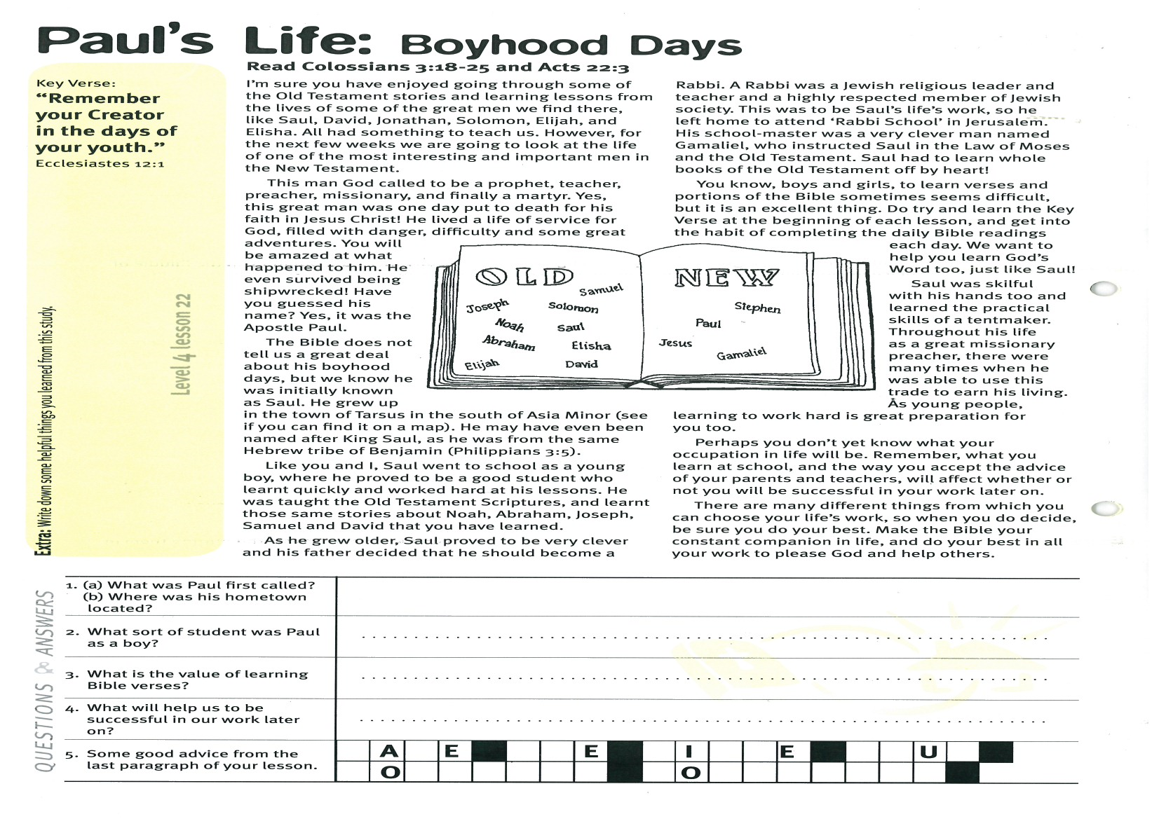
Extra: Write down some helpful things you have learned from this study.
Level 4 lesson 22
QUESTIONS & ANSWERS

Key Verse:
“Christ Jesus came into the world to save sinners – of whom I am the worst.”
1 Timothy 1:15
Of course, the Jewish leaders were opposed to such teaching. They entrusted Saul to lead a band of men who would wipe out these ‘Christians’ and their teaching. Saul, ignorant of the wrong that he was doing, eagerly agreed.
Stephen was one of the early Christian leaders and boldly shared the message of God’s love and forgiveness through Jesus’ sacrificial death and resurrection. One day he was summoned before the Jewish religious leaders. He reminded them plainly how they had treated the Lord Jesus and caused Him to be crucified. Bravely he told them that Jesus was truly the Son of God, their King and Messiah! Standing in the middle of the group, and looking up to Heaven, Stephen suddenly saw a wonderful vision. “I see the Heaven open and the Son of Man (Jesus) standing at the right hand of God” he cried!
This was too much! With cries of rage at his supposed blasphemy, the religious leaders grabbed Stephen and dragged him outside the city to stone him to death. Taking off their robes, they gave them to a young man to mind while they committed their terrible act. In full agreement, this young man watched as the rocks began raining down on Stephen. It was Saul of Tarsus.
What was Stephen’s reaction to this? Did he curse his enemies, or try to fight them? No. He simply knelt and prayed a most wonderful prayer. “Lord, don’t lay this sin to their charge,” he said, just as the Lord did on Calvary’s cross. Stephen died quickly, and so he became the first Christian to die for following Jesus (known as “a martyr”). Saul watched it all take place and still went on with his cruel work of rounding up the Christians, beating them, and putting them in prison.
However, something was about to change his life forever!

Read Acts 6:8-15; 7:54-60
and Acts 8:1-3
Saul became an influential and respected person in Jerusalem; he was considered a ‘model citizen’ and a ‘pillar of the community.’ He was clever and well educated, and lived a good life within the Jewish community. He was very religious and went to the temple every Sabbath day. He prayed and fasted regularly. He tried hard to please God by his worship and service and gave money generously to God’s work. He was very proud of how he lived, and felt sure that all his effort must be pleasing to God. Yet sadly, although Saul wanted to please God, he was going about it the wrong way. Even with all his knowledge of the Scriptures, he didn’t realise how badly mistaken he was!
About this time, a great stir began taking place in Jerusalem and the surrounding districts concerning ‘Jesus of Nazareth.’ He had been crucified some time earlier and the Jewish leaders had thought it was the end of Him. Now however, some people were going around claiming that Jesus had risen from the dead! They taught that Jesus was the “Lamb of God” and that His death had been the final sacrifice for the sin of the world; His resurrection proved that God had accepted His sacrifice. There was no need now, to continue with the animal sacrifices at the Temple.
They claimed that Jesus had ascended to Heaven in front of their eyes, and later, that God’s Holy Spirit had come down to earth to live in the hearts of all who followed the Lord Jesus. These ‘Christians’ said that by believing Jesus really was the Son of God and had paid the price for their sin, people could be forgiven and saved from God’s righteous judgement on their sin. And so the Christians were busily spreading the ‘Gospel’ message everywhere!

Paul’s Life: Persecuting Christians
1. What were the Christians busily doing after Jesus ascended, and the Holy Spirit had come down?
  S |  | R |  |  |  |  |  | G |  |  |  | E |  | G |  |  |  | E
  M |  |  |  |  |  | E |  | E |  |  |  |  | W
2. What was Saul entrusted to do?

3. Why was Stephen hated so much by the Jews?
4. How did Stephen treat his enemies?

5. What is a martyr?
Extra: Find out if people still get killed for following Jesus these days.
Level 4 lesson 23
QUESTIONS & ANSWERS

Paul’s Life: His Conversion
Key Verse:
“Therefore, if anyone is in Christ, he is a new creation; the old has gone, the new has come.”
2 Corinthians 5:17
Read Acts 9:1-16; 22:6-16;
and Acts 26:12-18
The Jewish leaders were sure that by stoning Stephen they had shown these Christians they meant business and so put an early end to this new ‘Christianity’ fad! Surely no-one would dare continue spreading these stories about Jesus Christ now, especially if it meant they would die?! Even Saul was convinced that all he did was right, and that God was pleased with him. He thought people who said that Jesus was really God needed to be taught a lesson. What blasphemy!
How Saul hated the Christians and their message of faith in Jesus Christ as Saviour! It went against everything he had been taught. He probably wondered sometimes, why Jesus’ followers were so brave and good, and why they seemed to be increasing in numbers as the days went by!
To his immense frustration, he even seemed to be helping spread the message himself! Whenever he drove these people away from their homes, they fled elsewhere, and then even more people became Christians! It just made him so mad and even more determined to stamp it out! Hearing of a large group of Christians in Damascus, he obtained a letter of authority from the Jewish leaders in Jerusalem, so that he could imprison and punish them.
Then, with a group of men around him, Saul set off for Damascus. He would stamp out Christianity, no matter what it took! Around midday though, as the group trudged along the dusty road, something amazing happened! Suddenly a great light shone brightly all around them, so bright they were all overcome and fell to the ground.

Then Saul heard a voice from Heaven, “Saul, Saul why are you persecuting Me?” Looking up to Heaven, Saul could see the form of the Son of God. “Who are you Lord?” he replied. Imagine his shock when the answer came, “I am Jesus, who you are persecuting.” How those words must have pierced his heart! The realisation struck him like a thunderbolt! He had been wrong all along - Jesus really was God! Now he had seen Jesus in the glory of Heaven and with his own eyes, too! Oh, what was he to do?
He knew one thing for sure; he now believed in Jesus, too! Humbled, Saul lay prone on the road. As the soldiers and the men with him looked on in amazement, he heard the voice of Jesus again, “Arise and go into the city and you will be told what you must do.” Struggling to his feet, Saul discovered he was blind! Someone took him gently by the hand and led him slowly along the road until they reached Damascus.
What a different arrival to what he had planned! Once proud and self-righteous, he now found himself humiliated and vulnerable; a shadow of his former self. His friends led him to Judas’ house in Straight Street, where they left him. All alone, Saul had time to think.
Somewhat afraid, yet strangely at peace within, he knew he had changed forever. In future, he knew that he too must tell everyone the truth about Jesus; that He really was God. That He had risen from the dead and really was alive! That Jesus was the Messiah sent from God to “save His people from their sin.”
It had not been the way the Jews had expected, but as he thought back over the Old Testament Scriptures, it suddenly made sense. Jesus was the Lamb of God, the sacrifice for sin. The old way was behind them; now it was simply a matter of faith in the blood of Jesus Christ. This was good news! He could hardly wait to tell someone!

1. Why did Saul hate the Christians so much?
2. Why was Saul going to the city of Damascus? (Add vowels) | T __ __ M P R __ S __ N C H R __ S T __ __ N S
3. Why do you think Jesus spoke to Saul the way He did?

4. What great change came over Saul’s life?
5. Did you learn anything special from this study? If so, what?
Extra: What does the Key Verse have to do with this story?
Level 4 lesson 24
QUESTIONS & ANSWERS
Please complete and return by post to
PSSM Bible Discovery, 5/399 New North Rd, Kingsland, Auckland 1021 or scan & email to info@biblediscovery.org.nz

