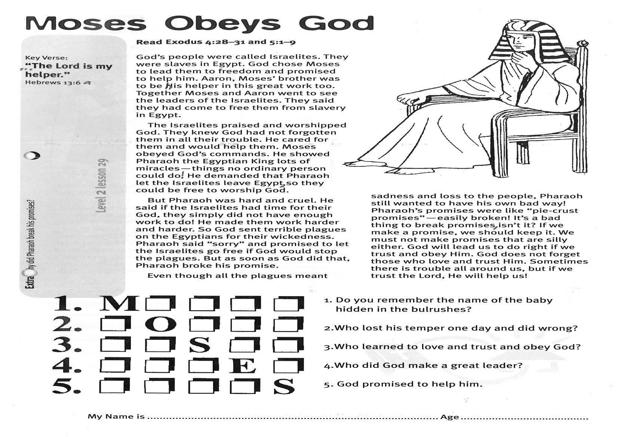

Key Verse:  
**“…The Lord is my helper.”**

Hebrews 13:6a

**Read Exodus 4:28-31; 5:1-9**God’s people were called Israelites. They were slaves in Egypt. God chose Moses to lead them to freedom and promised to help him. Aaron, Moses’ brother, was to be his helper in this great work, too. Together Moses and Aaron went to see the leaders of the Israelites. They said they had come to free them from slavery in Egypt.

The Israelites praised and worshipped God. They knew God had not forgotten them in all their trouble. He cared for them and would help them. Moses obeyed God’s commands. He showed Pharaoh, the Egyptian King, lots of miracles - things no ordinary person could do! He demanded that Pharaoh let the Israelites leave Egypt, so they could be free to worship God.

But Pharaoh was hard and cruel. He said if the Israelites had time for their God, they simply did not have enough work to do! He made them work harder and harder. So God sent terrible plagues on the Egyptians for their wickedness. Pharaoh said “sorry” and promised to let the Israelites go free if God would stop the plagues. But as soon as God did that, Pharaoh broke his promise!

**Moses Obeys God**

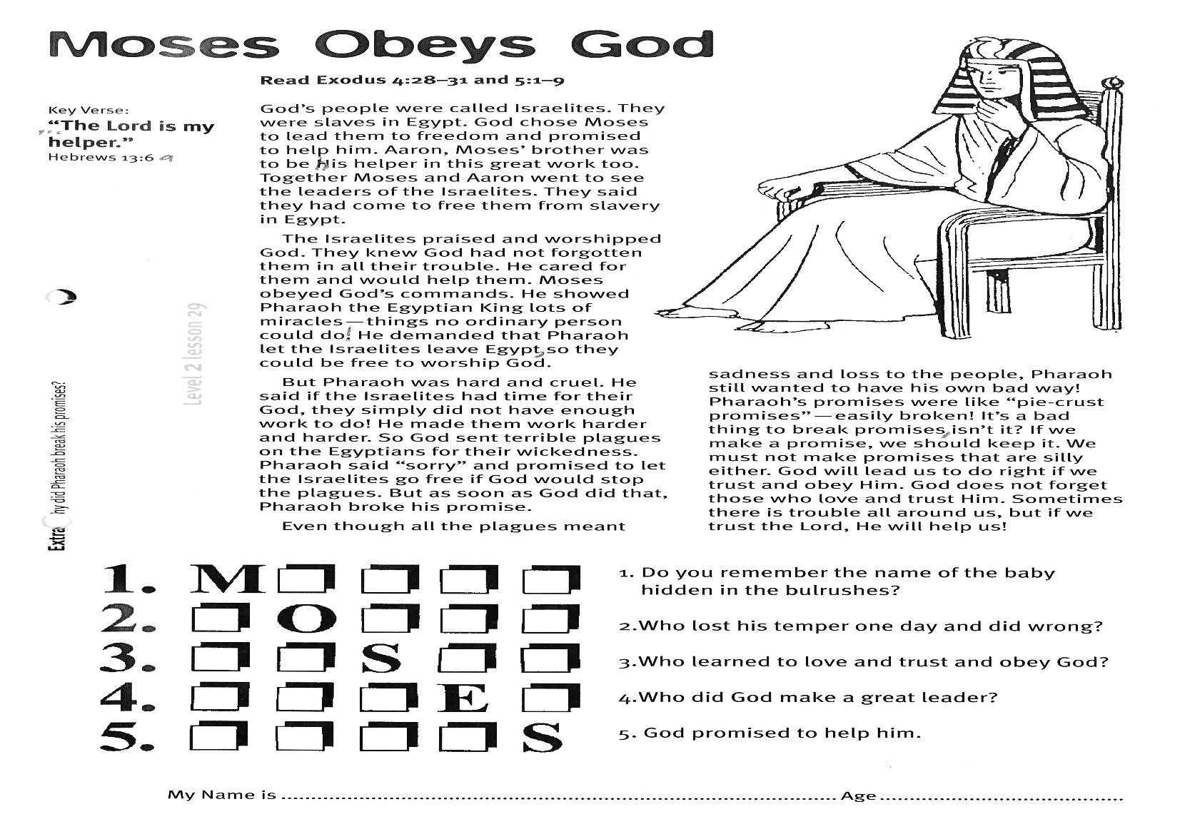

**Extra:** Why did Pharaoh break his promises?

Even though all the plagues meant sadness and loss to the people, Pharaoh still wanted to have his own bad way! Pharaoh’s promises were like “pie-crust promises” - easily broken! It’s a bad thing to break promises, isn’t it? If we make a promise, we should keep it. We must not make promises that are silly either. God will lead us to do right if we trust and obey Him. God does not forget those who love and trust Him. Sometimes there is trouble all around us, but if we trust the Lord, He will help us!

My Name is________________________________________ Age ______________

**Level 2 lesson 29**

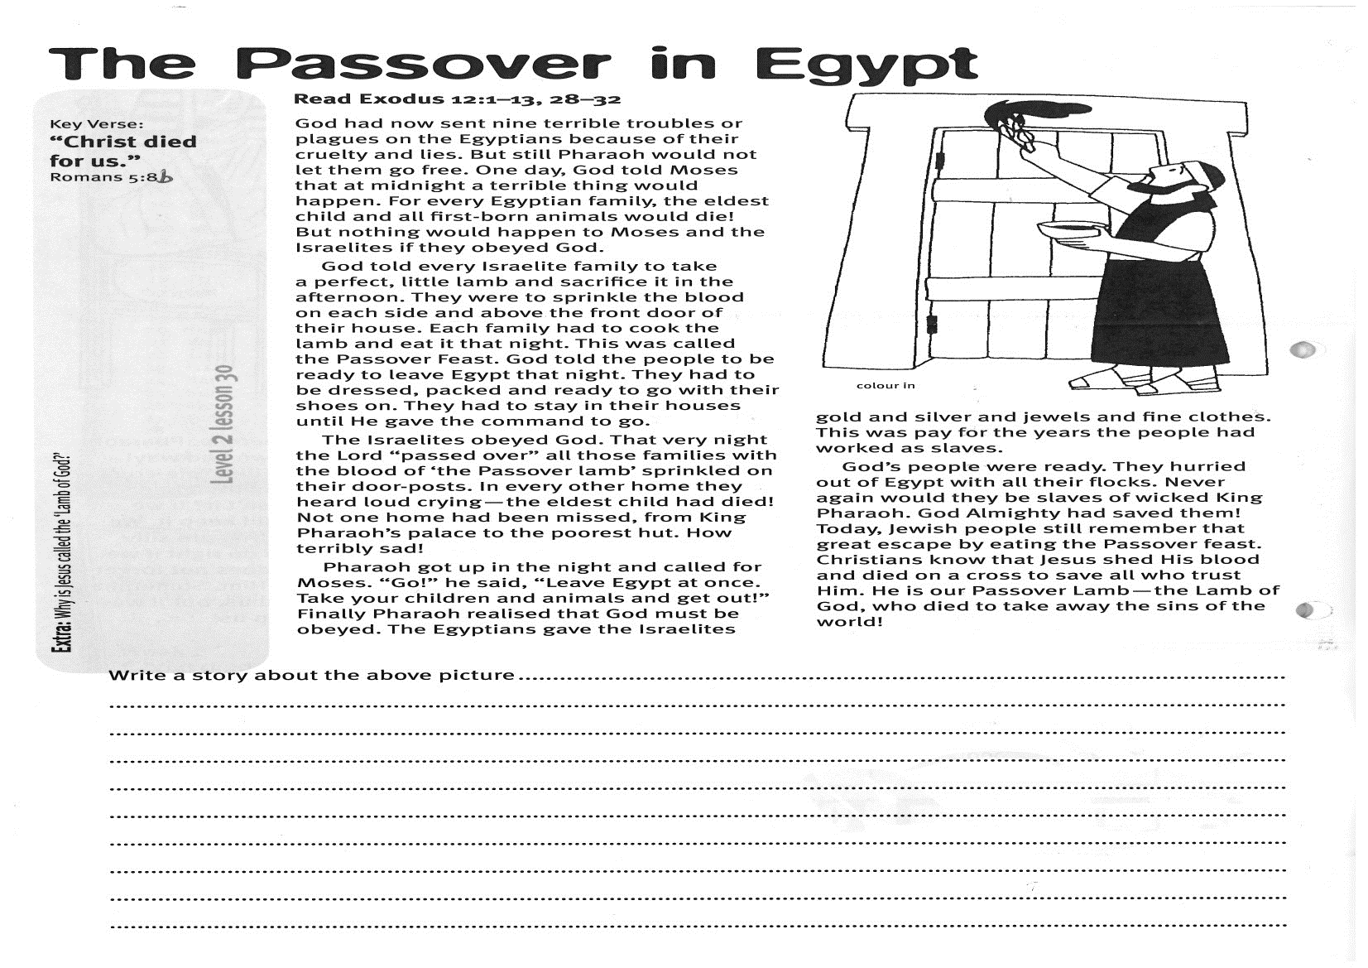

Key Verse:  
**“Christ died for us.”**

Romans 5:8b

**Read Exodus 12:1-13, 28-32**

God had now sent nine terrible troubles or plagues on the Egyptians because of their cruelty and lies. But still Pharaoh would not let them go free. One day, God told Moses that at midnight a terrible thing would happen. For every Egyptian family, the eldest child and all first-born animals would die! But nothing would happen to Moses and the Israelites if they obeyed God.

God told every Israelite family to take a perfect, little lamb and sacrifice it in the afternoon. They were to sprinkle the blood on each side and above the front door of their house. Each family had to cook the lamb and eat it that night. This was called the Passover Feast. God told the people to be ready to leave Egypt that night. They had to be dressed, packed and ready to go with their shoes on. They had to stay in their houses until He gave the command to go.

The Israelites obeyed God. That very night the Lord “passed over” all those families with the blood of ‘the Passover lamb’ sprinkled on their door-posts. In every other home they heard loud crying - the eldest child had died! Not one home had been missed, from King Pharaoh’s palace to the poorest hut. How terribly sad!

**The Passover in Egypt**

**Extra:** Why is Jesus called the ‘Lamb of God’?

**Level 2 lesson 30**

Write a story about the above picture:

……………………………………………………………………………………………………………………………………………………………………………………………………………………………………………………………………………………………………………………………………………………………………………………………………………………………………………………………………………………………………………………………………………………………………………………………………………………………………………………………………………………………………………………………………………………………………………………………………………………………………………………………………………….

Pharaoh got up in the night and called for Moses. “Go!” he said, “Leave Egypt at once. Take your children and animals and get out!” Finally Pharaoh realised that God must be obeyed. The Egyptians gave the Israelites gold and silver and jewels and fine clothes. This was pay for the years the people had worked as slaves.

God’s people were ready. They hurried out of Egypt with all their flocks. Never again would they be slaves of wicked King Pharaoh. God Almighty had saved them! Today, Jewish people still remember that great escape by eating the Passover feast. Christians know that Jesus shed His blood and died on a cross to save all who trust Him. He is our Passover Lamb - the Lamb of God, who died to take away the sins of the world!

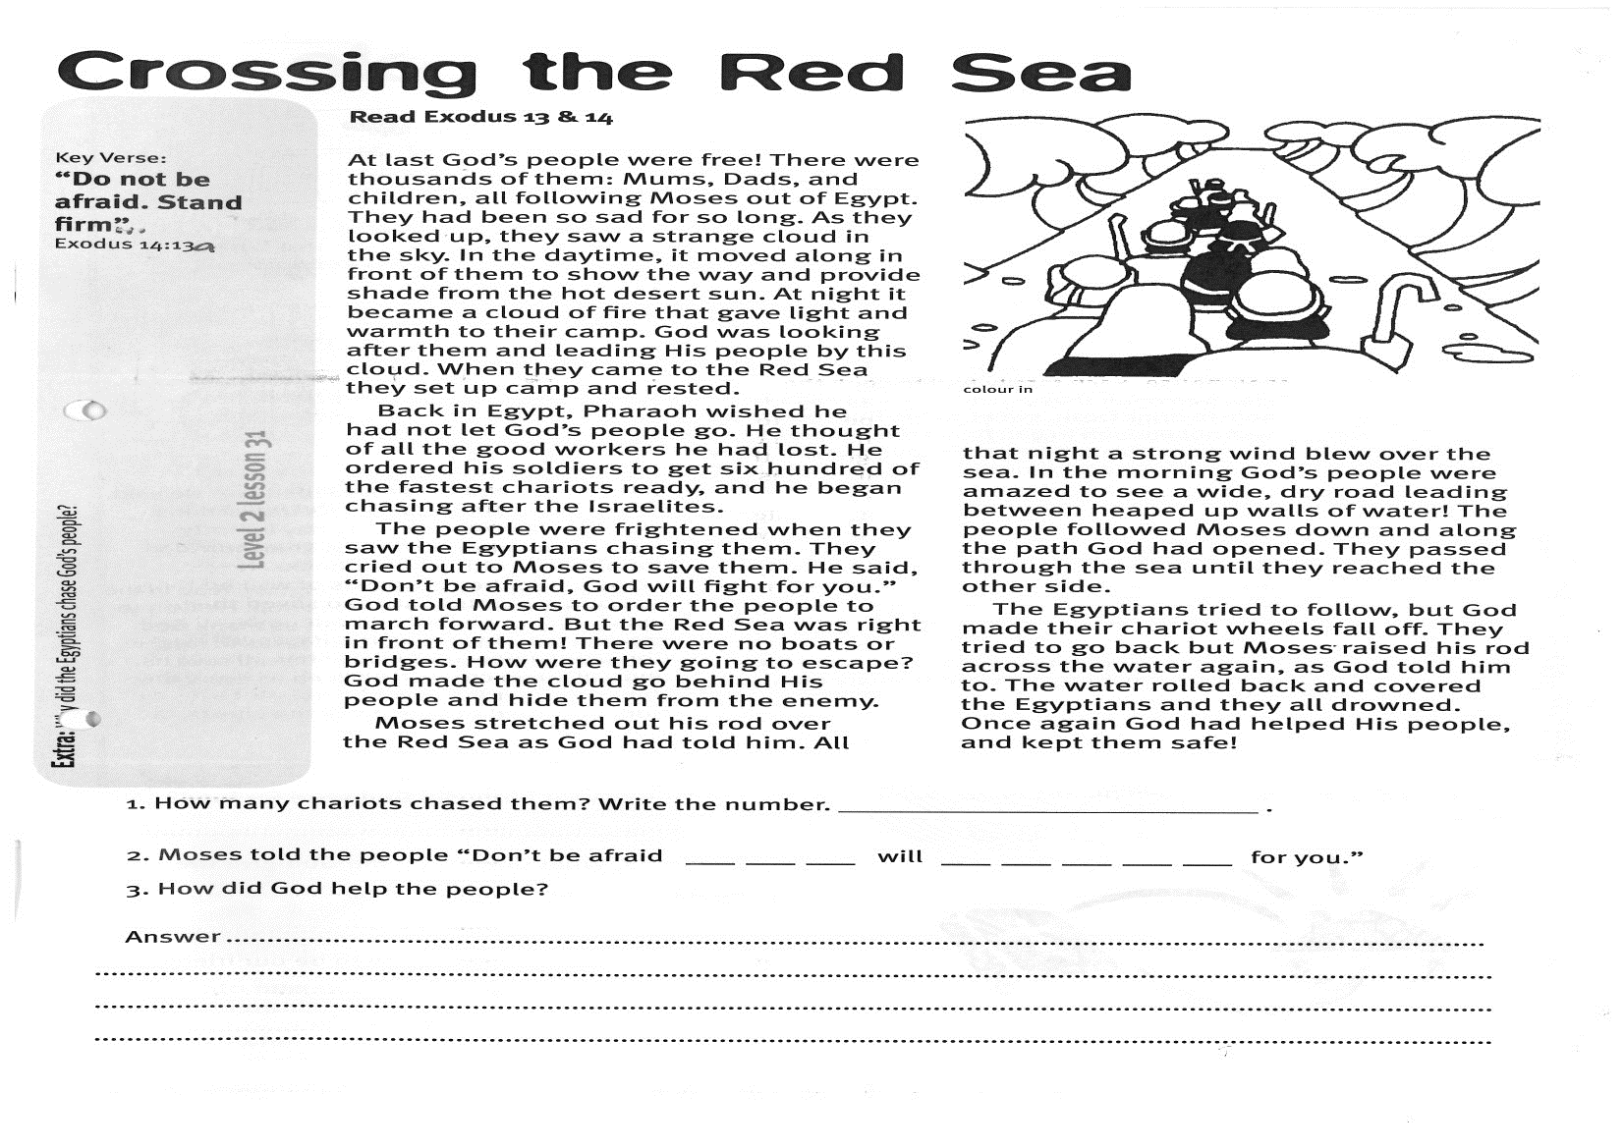

**Read Exodus 13 & 14**  
At last God’s people were free! There were thousands of them: Mums, Dads, and children, all following Moses out of Egypt. They had been so sad for so long. As they looked up, they saw a strange cloud in the sky. In the daytime, it moved along in front of them to show the way and provide shade from the hot desert sun. At night it became a cloud of fire that gave light and warmth to their camp. God was looking after them and leading His people by this cloud. When they came to the Red Sea they set up camp and rested.

Back in Egypt, Pharaoh wished he had not let God’s people go. He thought of all the good workers he had lost. He ordered his soldiers to get six hundred of the fastest chariots ready, and he began chasing after the Israelites.

The people were frightened when they saw the Egyptians chasing them. They cried out to Moses to save them. He said, “Don’t be afraid, God will fight for you.” God told Moses to order the people to march forward. But the Red Sea was right in front of them! There were no boats or bridges. How were they going to escape? God made the cloud go behind His people and hide them from the enemy.

Key Verse:  
**“Do not be afraid. Stand firm…”**

Exodus 14:13a

**Crossing the Red Sea**

Moses stretched out his rod over the Red Sea as God had told him. All that night a strong wind blew over the sea. In the morning God’s people were amazed to see a wide, dry road leading between heaped up walls of water! The people followed Moses down and along the path God had opened. They passed through the sea until they reached the other side.

The Egyptians tried to follow, but God made their chariot wheels fall off. They tried to go back but Moses raised his rod across the water again, as God told him to. The water rolled back and covered the Egyptians and they all drowned. Once again God had helped His people, and kept them safe!

**Extra:** Why did the Egyptians chase God’s people?

1. How many chariots chased them? Write the number ……………………………………………

2. Moses told the people “Don’t be afraid __ __ __ will __ __ __ __ __ for you.”

3. How did God help the people? Answer…………………………………………………………………………………………………………………………………………………………………………………………………………………………………………………………………………………………………………………………………………………………………………………………………………………………….

**Level 2 lesson 31**

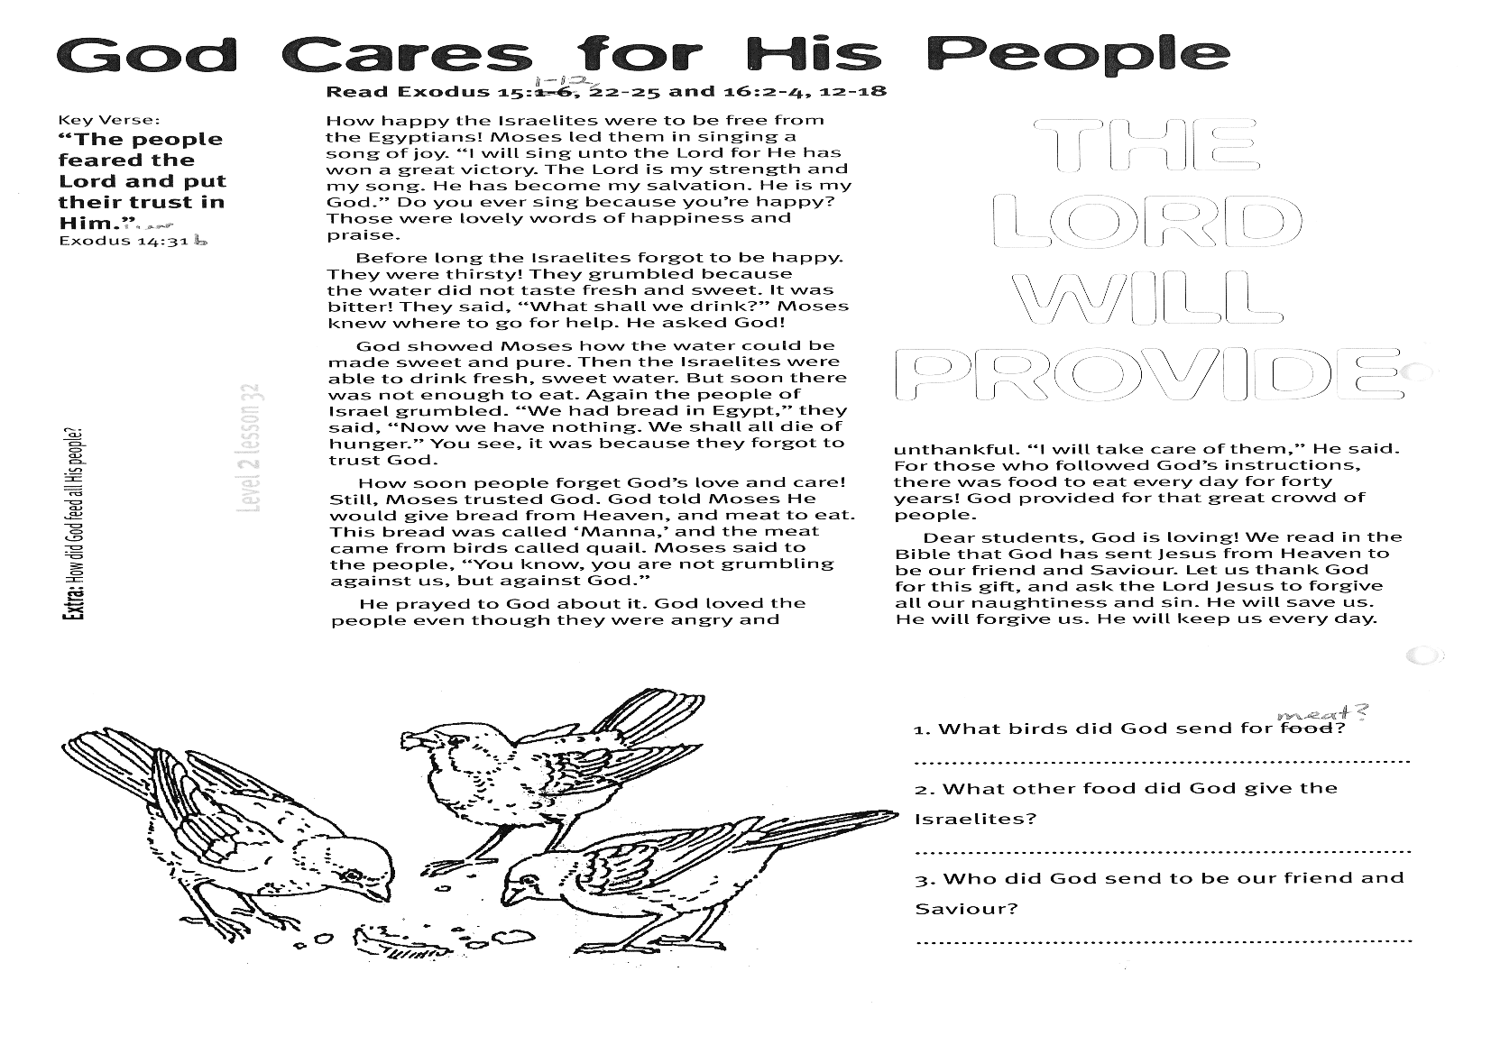

**Extra:** How did God feed all His people?

God told Moses He would give bread from Heaven, and meat to eat. This bread was called ‘Manna,’ and the meat came from birds called quail. Moses said to the people, “You know, you are not grumbling against us, but against God.”

He prayed to God about it. God loved the people even though they were angry and unthankful. “I will take care of them,” He said. For those who followed God’s instructions, there was food to eat every day for forty years! God provided for that great crowd of people.

Dear students, God is loving! We read in the Bible that God has sent Jesus from Heaven to be our friend and Saviour. Let us thank God for this gift, and ask the Lord Jesus to forgive all our naughtiness and sin. He will save us. He will forgive us. He will keep us every day.

**The Lord will provide**

Key Verse: **“The people feared the lord and put their trust in Him…”**

Exodus 14:31b

Please complete and return by post to   
**PSSM Bible Discovery, 5/399 New North Rd, Kingsland, Auckland 1021** or scan & email to **info@biblediscovery.org.nz**

1. What birds did God send for meat?

………………………………………………………………………………

2. What other food did God give the Israelites?

………………………………………………………………………………

3. Who did God send to be our friend and Saviour?

………………………………………………………………………………

**God Cares for His People**

**Read Exodus 15:1-12, 22-25  
and Exodus 16:2-4, 12-18**

How happy the Israelites were to be free from the Egyptians! Moses led them in singing a song of joy. “I will sing unto the Lord for He has won a great victory. The Lord is my strength and my song. He has become my salvation. He is my God.”   
Do you ever sing because you’re happy? Those were lovely words of happiness and praise.

Before long the Israelites forgot to be happy. They were thirsty! They grumbled because the water did not taste fresh and sweet. It was bitter! They said, “What shall we drink?” Moses knew where to go for help. He asked God!

God showed Moses how the water could be made sweet and pure. Then the Israelites were able to drink fresh, sweet water. But soon there was not enough to eat. Again the people of Israel grumbled. “We had bread in Egypt,” they said, “Now we have nothing. We shall all die of hunger.” You see, it was because they forgot to trust God.

How soon people forget God’s love and care! Still, Moses trusted God.

**Level 2 lesson 32**