

**A Father’s Faith in Jesus**

**Read Mark 5:21-43**Sometimes, we forget that God knows everything, and we can’t understand why He doesn’t answer our prayers on time. But because God is so wise, He always knows the best time to act.

The Bible teaches us that God is powerful enough to do anything. In Genesis 1, God made the whole world by just speaking! It also teaches that God is everywhere at the same time; that there is nothing He doesn’t see; nothing He doesn’t know. It’s true. King David asked in Psalm 139:7-10, “Where can I go from your Spirit? Where can I flee from your presence?” There’s nowhere you can go that God won’t be there, too.  
Sometimes, even though we believe that God is all-powerful, and that God is everywhere at once, we can doubt whether God will do everything in the best time. Today’s lesson will show that we have nothing to worry about.

One day, as Jesus was stepping out of a small boat after crossing Lake Galilee, a man named Jairus ran up to Him and fell at His feet. ‘My little daughter is dying,’ he said. ‘Please come and heal her!’ The Lord Jesus agreed and set off to Jairus’ house. On the way, a large crowd of people were pushing and jostling Jesus, and a woman who had been sick for twelve years reached out and touched His cloak. She knew Jesus had the power to heal her and, sure enough, she was healed at that very moment!

The Lord stopped and asked, “Who touched Me?” The disciples must have thought Jesus was tricking them. “Master,” they said, “There’s a whole mob here pushing up against you, and you ask, ‘Who touched Me?’”

Key Verse:  
**“Ask and it will be given to you; seek and you will find…”**

Matthew 7:7a



My Name is ……………………………………………………… Age…………

***Tick a box on each line to show which sentences are true and which are false!***

Jesus of course, knew who had touched Him, but he wanted the woman to come forward herself. Finally, she stepped forward and told Jesus what she’d done. The Lord blessed her for her faith.  
However, all this time, Jairus’ daughter lay in bed, as sick as could be. Now imagine if you were Jairus! What would you have said? “Hurry up Jesus! Can’t you wait until later to heal this woman? She’s been sick for twelve years… another few hours won’t hurt!” But we don’t read that he said anything like that.  
  
It seems Jairus not only trusted that Jesus was powerful enough to heal his daughter, but that He was wise enough to be able to do it at the right time. Jairus didn’t try to rush Jesus - even when messengers came to say his daughter had died. Jesus encouraged Jairus not to worry, but to believe in Him. Jairus trusted that the Lord knew what He was doing.  
  
When they finally arrived at Jairus’ house, the people were all mourning for the little girl who had died. Jesus sent them all from the room and then went in and took her by the hand. “Little girl,” He said, “I say to you: Get up!” And she did! Jesus raised Jairus’ daughter from the dead. What an amazing example of faith Jairus is.   
Do you totally trust in the Lord Jesus like that? Not just that He is all-powerful, but all-wise and all-good as well? When it comes to trusting God, we must trust Him completely!

**Level 3 lesson 29**

**Extra:** What are some things that can stop us trusting Jesus?

1. What kept Jesus from getting to Jairus’ house quickly?

_____________________________________

_____________________________________

_____________________________________

_____________________________________

_____________________________________

2. Why was Jairus so patient?  
_____________________________________  
_____________________________________  
_____________________________________  
_____________________________________



Key Verse:  
**“He [Jesus] was delivered over to death for our sins and was raised to life for our justification.”**

Romans 4:25

**Read Luke 7:1-10**“I don’t have enough faith to trust God for things!” Have you ever said that? Well, it’s a good thing that the size and strength of our faith doesn’t matter as much as the size and strength of the God we have faith in!

‘Concentrated Formula!’ Have you ever read that on the side of a bottle or the back of a box? Some cleaning goods, detergents, and laundry powders have ‘concentrate’ written on them, and you only need a tiny amount to do the cleaning you want. True faith is like that. In fact, Jesus once said that if you have faith the size of a mustard seed, you can move mountains. (Matthew 17:20)

One day, as the Lord Jesus arrived in the city of Capernaum, He met a man who had enough faith to believe in Him for something really BIG! The man was a Roman Centurion, and he sent some of his friends to ask Jesus for His help. The Centurion’s servant, whom he cared for very much, was sick and about to die. Jesus was his only hope! The people pleaded with Jesus to help the Centurion.

Jesus went with them, but before they arrived at the Centurion’s house, he sent Jesus a message: “Lord, you don’t have to come all this way. I don’t deserve to have you in my house. Just say the word and my servant will be healed.

**A Foreigner’s Faith in Jesus**



1. How much faith did Jesus say we had to have to be able to do great things?

_________________________________________

__________________________________________________________________________________

2. How do we know that the Centurion had great faith in the Lord Jesus?

_________________________________________

___________________________________________________________________________________________________________________________

***Choose words from the WORD BANK below to finish this sentence:***

I’m an officer over many men and I know how authority works. I believe that you have the authority to say it, and it will happen.” Isn’t it amazing that this man, a Roman, who knew only a little about Jesus, trusted Him so much?

Jesus was very impressed by this man’s faith. He said, “I have not found faith like this in all of Israel!” Sadly, many of the Jews refused to believe in Jesus, even though He had done so much to show that He was their Messiah. Jesus is the Saviour that God sent to save them and us! When the messengers arrived back at the Centurion’s home, they found that his servant had been completely healed.

Are you like this Centurion? He didn’t know much about Jesus, but the little he did know, he believed with **all** his heart. That pleased the Lord so much. A little faith can go a long way, when it’s faith in God!

**Level 3 lesson 30**

**Extra:** Write some reasons you have for trusting in the Lord.



**Read Mark 10:46-52 and Luke 18:1-8**  
‘Knock, Knock, Knock.’ When you knock on a door, it’s hard to know how long you’re going to be standing there before someone answers. Sometimes it’s one knock, sometimes, two, and sometimes you wonder if your arm will fall off before someone answers! When it comes to prayer, it’s not a once-for-all shot. The Lord loves to see our faithfulness in praying to Him. He never tires of hearing the voice of those who love Him. Those who have true faith will ‘keep knocking’ because they know the Lord will answer!

Sometimes when we ask the Lord for something, He doesn’t seem to answer right away. That’s not because He’s mean. Instead, He just wants us to learn to wait on Him and trust in His timing. God loves to see those who trust Him enough not to give up asking Him for what they need.

One day, as Jesus and His disciples were leaving Jericho, they passed a blind beggar called Bartimaeus. He heard the commotion of the large crowd that surrounded Jesus and asked what was going on. “It’s Jesus of Nazareth,” someone said. Jesus! At these words Bartimaeus’ heart leapt! Jesus of Nazareth, the famous Teacher and Healer who claimed to be the Messiah! Bartimaeus knew this was his one chance to be healed of his blindness! He began to shout.

Suddenly, above the bustling noise of the crowd, people could hear his pleading voice calling, “Jesus, Son of David, have mercy on me!” Many people told him to be quiet.

**A Blind Man’s Faith in Jesus**

Key Verse:  
**“Oh the depth of the riches of the wisdom and knowledge of God…”**

Romans 11:33a

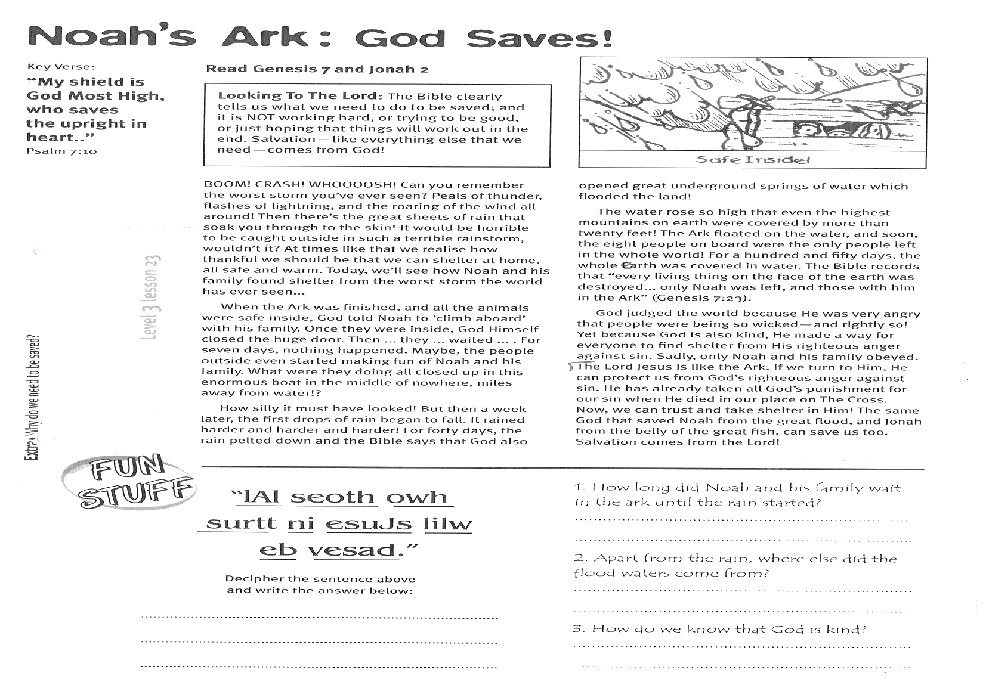

1. Why was Bartimaeus eager to get to Jesus?

____________________________________________

________________________________________________________________________________________

2. What lessons can we learn from Bartimaeus’ healing?

___________________________________________

___________________________________________

___________________________________________

**Level 3 lesson 31**

**Extra:** How do we know God is interested in us?

They probably thought that Jesus wouldn’t want anything to do with a dirty, blind old beggar!

But he cried out even louder. Jesus stopped and said, “Call him.” Isn’t it great to know that the Lord Jesus is interested in the poor, sick, weak, and blind people? There isn’t anyone that He is not interested in - and that includes you!

Seeing Jesus’ kind response, the people changed their tune! “Come on. Cheer up!” they said. “Jesus is calling you!” Bartimaeus didn’t need to be told twice. Wrapping his old cloak around him, he jumped to his feet and hobbled to Jesus as quickly as he could. He was so eager to get to Him. Jesus asked him what he wanted and Bartimaeus earnestly replied, “Lord, that I may see!” The Lord Jesus responded with the words that filled Bartimaeus’ heart with joy, “Go, your faith has healed you.” Immediately, Bartimaeus’ sight was restored and he followed Jesus down the road.

Here’s our lesson: Never give up! When someone really trusts in the Lord, they keep on trusting Him for what they need, because they know He is the God who hears and answers prayer!



**Read Mark 2:1-12**“ACTION!” On a film set, everyone rushes about to get ready for the shot. When the actors are in place, and all the lighting and props and cameras are ready, the director shouts, “ACTION!” The same is true of real faith: once we say we believe in the Lord Jesus, it’s time to do something about it. It’s time to ACT!

What we do (or don’t do) shows whether we believe (or don’t believe) something. It’s easy for someone to say that they believe in the Lord Jesus; that they believe He lived on earth over 2000 years ago; that they believe He was powerful and could do miracles; they could even say that they believe He was the Son of God. Whether or not they do anything about it, shows how much they really believe, or if their words are just empty with no real faith! Today, we’re going to read about some men who believed in the power of Jesus and did something about it!

For a while, the Lord Jesus was very popular during his earthly ministry. One day, He was speaking in a house, but so many people crowded in to hear Him speak, that there was hardly room to move! There were people crowded around the door and looking in the windows. There was no normal way anyone else could get in to see Jesus. But there was a crippled man on a stretcher whose friends knew that if they could only get him to Jesus, he could be healed!

Key Verse:  
**“Without faith it is impossible to please God…”**

Hebrews 11:6a

**A Sick Man’s Faith in Jesus**

**Answer:**

With the door and windows blocked, the only option left was the roof! So the men took their crippled friend up onto the roof, made an opening above where Jesus was sitting, and lowered him down to where Jesus could heal him. Jesus saw the great faith of these men, and that’s exactly what He did! The poor man had been paralysed for many years, but at Jesus’ command, he stood up, picked up his stretcher, and carried it home! That’s amazing!

The crippled man and his friends had real faith, and we can see that by what they did! They believed in Jesus, in His power and goodness, and so they had gone to Him - no matter how difficult or even impossible it seemed to be. They had completely believed that Jesus had the power to heal their friend, and that He was good and would not say “No” to them. Do you believe in Jesus? Do you have faith in God? Is it the kind of faith that believes in God (no matter what) and seeks to please Him in everything?

**Level 3 lesson 32**

**Extra:** What made this event so amazing?

1. Why couldn’t the crippled man’s friends get to Jesus?  
  
________________________________________  
  
________________________________________  
  
________________________________________

­­­­­

2. Why did these men try so hard to get to Jesus?

_______________________________________

_______________________________________

_______________________________________



***See if you can solve this word puzzle. Write the answer on the lines below:***_____________________________________________________________________________________________



Start here

Please complete and return by post to   
**PSSM Bible Discovery, 5/399 New North Rd, Kingsland, Auckland 1021** or scan & email to **info@biblediscovery.org.nz**