
1st Journey Ends
Key Verse:
“Then the disciples went out and preached everywhere, and the Lord worked with them and confirmed His Word…”
Mark 16:20

Read Acts 14:19-28
and Galatians 1:11-24
Remember how Paul and Barnabas healed a crippled man in the town of Lystra, and the pagan people wanted to worship them? Well, after explaining that they were just ordinary men and that it was only God’s power which had healed the man, things changed quite dramatically! Before long, this crowd of people who had been ready to worship them as gods became angry and violent! They grabbed Paul and dragged him through the streets and outside the city. Then they stoned him with large rocks and left him for dead, lying in a pool of blood!
Some of the Christians went to Paul as soon as his enemies had left him and to their great joy and amazement he woke up! He was still alive, but what a mess! Slowly they helped him back into one of their homes, where they bathed and bandaged his wounds.
The next day Paul left town. It was better for him to leave Lystra quickly, but it must have been difficult for him: he would have been “black and blue” with bruises. The Lord obviously strengthened him to travel so soon after this terrible experience. How keen he was to spread the glad news that had changed his own life completely!
Paul and Barnabas wanted to call at the places they had visited previously and encourage all the new Christians. What a time of rejoicing and blessing it was as they met the young Christians in the different towns. They were glad to see the Apostles again, and eager to learn more of God’s Word. Sometimes there were problems to sort out and the two missionaries were kept very busy.

1. What did the people of Lystra do to Paul?  Code: 1=a, 2=b, 3=c, etc | __ __ __ __ __ __ __ __ __ __ __ __ __ __  20 18 9 5 4 20 15 11 9 12 12 8 9 13
2. What made Paul so victorious?
3. How long had Paul and Barnabas been away on missionary work?
4. How can we be missionaries?
5. What has the Lord done for you?
Level 3 lesson 1
Extra: Find out about missionaries from your church and how you can help them.
Level 4 lesson 29
QUESTIONS & ANSWERS
Key Verse:
“Jesus said, ‘I tell you the truth, unless a man is born again, he cannot see the kingdom of God.’”
John 3:3
Of course, they never stopped preaching the Gospel, telling everyone that Jesus Christ was alive and to trust Him as Saviour.
How Paul loved Jesus! He had been called to be a witness for Him and that was his main focus in life now. Some of us profess to love Christ and be His disciples, but I wonder how we face the hardships that come our way? Sometimes we are not very willing to serve the Lord gladly, even when things go well and we have no opposition! There was one thing that made Paul so triumphant and victorious. He knew that Jesus was really alive! He could say, “I can do all things through Christ who strengthens me.” (Philippians 4:13) The Lord Jesus will help you, too, if you trust Him!
Now, finally, they were sailing across the sparkling waters of the Mediterranean Sea, bound for Antioch. What a reunion it must have been on their arrival! Three years had passed since Paul and Barnabas had first set out and their friends had waved them goodbye and now, here they were home again. The disciples and many other Christians gathered to hear Paul and Barnabas tell of their many interesting experiences; how God had protected and blessed them and how many had trusted in Jesus Christ. Everybody praised God at this good news!
Today as God’s servants, we too must still share the good news of Jesus. Although we may not travel overseas, we can be missionaries where we are; telling others about the Lord Jesus and praying for and supporting those who go overseas.

My Name is _____________________________________________ Age ___________
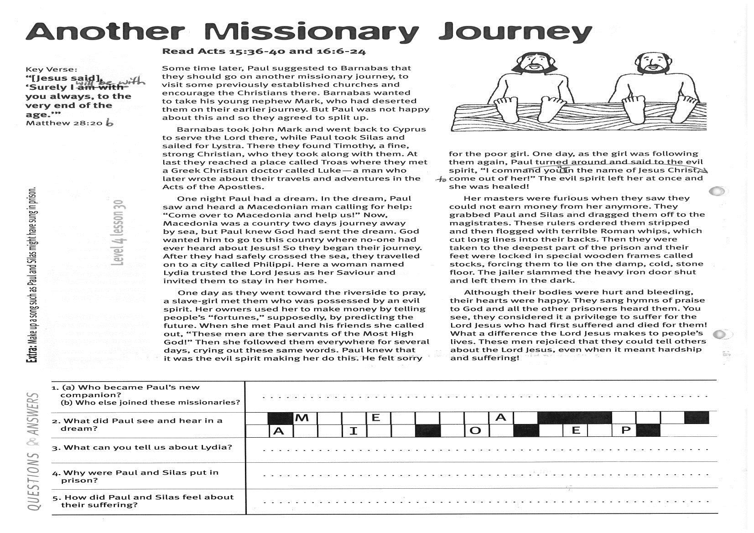
Another Missionary Journey
Read Acts 15:36-40
and Acts 16:6-25
Some time later, Paul suggested to Barnabas that they should go on another missionary journey, to visit some previously established churches and encourage the Christians there. Barnabas wanted to take his young nephew Mark, who had deserted them on their earlier journey. But Paul was not happy about this and so they agreed to split up.
Barnabas took John Mark and went back to Cyprus to serve the Lord there, while Paul took Silas and sailed for Lystra. There they found Timothy, a fine, strong Christian, who they took along with them. At last they reached a place called Troas where they met a Greek Christian doctor called Luke - a man who later wrote about their travels and adventures in the Acts of the Apostles.
One night Paul had a dream. In the dream, Paul saw and heard a Macedonian man calling for help: “Come over to Macedonia and help us!” Now, Macedonia was a country two days journey away by sea, but Paul knew God had sent the dream. God wanted him to go to this country where no-one had ever heard about Jesus! So they began their journey. After they had safely crossed the sea, they travelled on to a city called Philippi. Here a woman named Lydia trusted the Lord Jesus as her Saviour and invited them to stay in her home.
One day as they went toward the riverside to pray, a slave-girl met them who was possessed by an evil spirit. Her owners used her to make money by telling people’s “fortunes,” supposedly, by predicting the future. When she met Paul and his friends she called out, “These men are the servants of the Most High God!”
1. (a) Who became Paul’s new companion? (b) Who also joined these missionaries?
2. What did Paul see and hear in a dream?
   |  | M |  |  | E |  |  | N |  | A |  |  |  |  |  | A
   | A |  |  | I |  |  |  |  | O |  |  |  | E |  | P
3. What can you tell us about Lydia?
4. Why were Paul and Silas put in prison?
5. How did Paul and Silas feel about their suffering?
Extra: Make up a song such as Paul and Silas might have sung in prison.
Level 4 lesson 30
QUESTIONS & ANSWERS
Key Verse:
“…[Jesus said] ‘Surely I will be with you always, to the very end of the age.’ “
Matthew 28:20b

Then she followed them everywhere for several days, crying out these same words. Paul knew that it was the evil spirit making her do this. He felt sorry for the poor girl. One day, as the girl was following them again, Paul turned around and said to the evil spirit, “In the name of Jesus Christ, I command you to come out of her!” The evil spirit left her at once and she was healed!
Her masters were furious when they saw they could not earn money from her anymore. They grabbed Paul and Silas and dragged them off to the magistrates. These rulers ordered them stripped and then flogged with terrible Roman whips, which cut long lines into their backs. Then they were taken to the deepest part of the prison and their feet were locked in special wooden frames called stocks, forcing them to lie on the damp, cold, stone floor. The jailer slammed the heavy iron door shut and left them in the dark.
Although their bodies were hurt and bleeding, their hearts were happy. They sang hymns of praise to God and all the other prisoners heard them. You see, they considered it a privilege to suffer for the Lord Jesus who had first suffered and died for them!
What a difference the Lord Jesus makes to people’s lives. These men rejoiced that they could tell others about the Lord Jesus, even when it meant hardship and suffering!

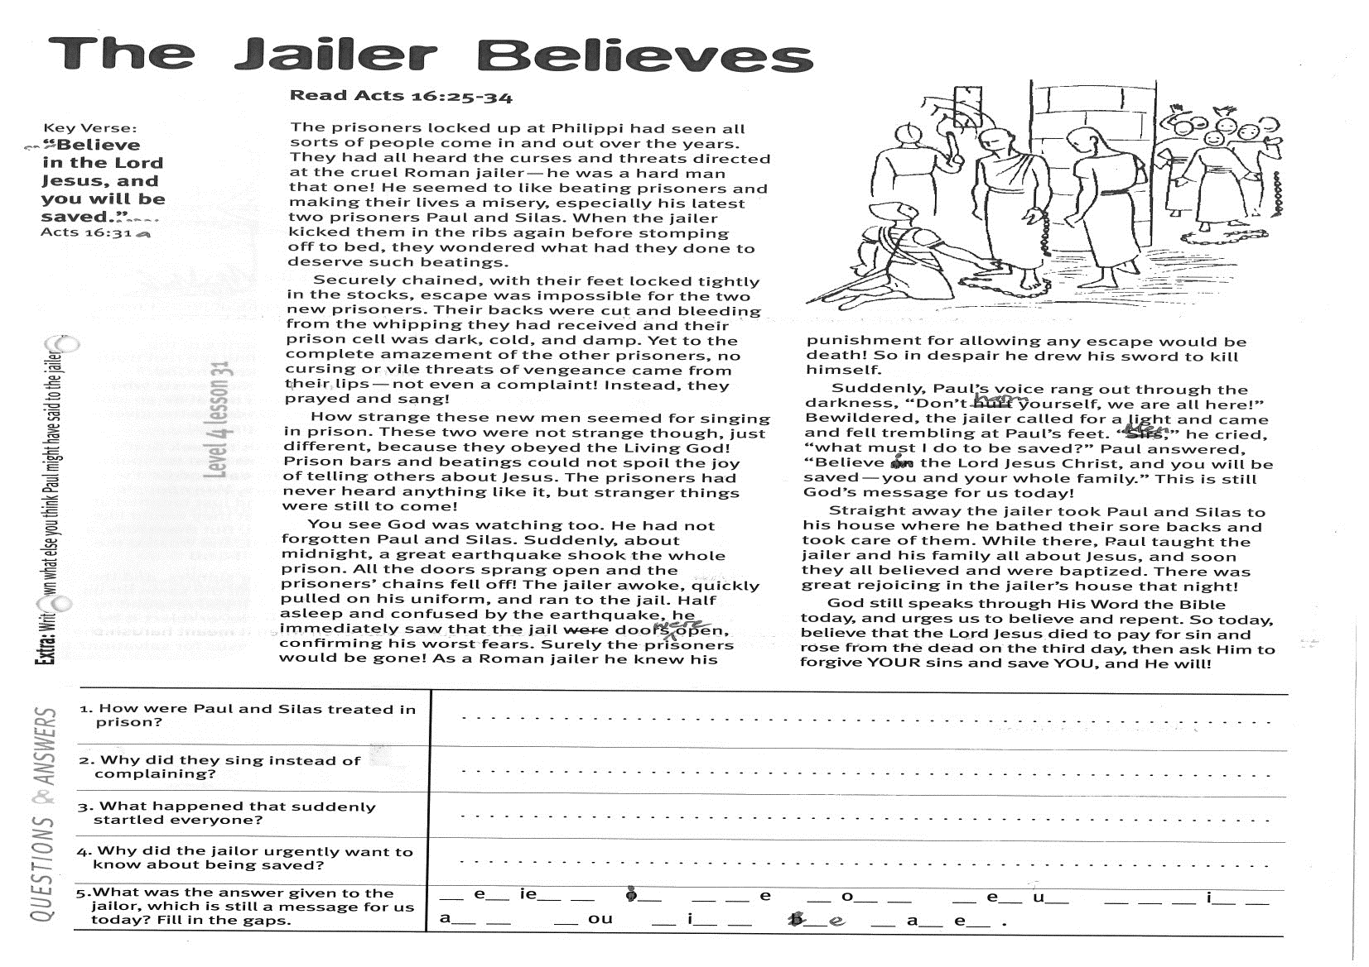
Key Verse:
“…Believe in the Lord Jesus, and you will be saved…”
Acts 16:31a
Read Acts 16:25-34
The prisoners locked up at Philippi had seen all sorts of people come in and out over the years. They had all heard the curses and threats directed at the cruel Roman jailer - he was a hard man, that one! He seemed to like beating prisoners and making their lives a misery, especially his latest two prisoners, Paul and Silas. When the jailer had locked them securely (and probably roughly) before stomping off to bed, they wondered what had they done to deserve such treatment.
Securely chained, with their feet locked tightly in the stocks, escape was impossible for the two new prisoners. Their backs were cut and bleeding from the whipping they had received and their prison cell was dark, cold, and damp. Yet to the complete amazement of the other prisoners, no cursing or vile threats of vengeance came from their lips - not even a complaint! Instead, they prayed and sang!
How strange these new men seemed for singing in prison. These two were not strange though, just different; because they obeyed the Living God! Prison bars and beatings could not spoil the joy of telling others about Jesus. The prisoners had never heard anything like it, but stranger things were still to come!
You see God was watching, too. He had not forgotten Paul and Silas. Suddenly, about midnight, a great earthquake shook the whole prison. All the doors sprang open and the prisoners’ chains fell off! The jailer awoke, quickly pulled on his uniform, and ran to the jail. Half asleep and confused by the earthquake, he immediately saw that the jail doors were open, confirming his worst fears.
Surely the prisoners would be gone!
The Jailer Believes
1. How were Paul and Silas treated in prison?
2. Why did they sing instead of complaining?

3. What happened that suddenly startled everyone?
4. Why did the jailor urgently want to know about being saved?

5. What was the answer given to the jailor, which is still a message for us today? | __ e __ i e __ __ i __ __ __ e __ o __ __ __ e __ u __  __ __ __ i __ __ a __ __ __ o u __ i __ __ __ e __ a __ e__
Extra: Write down what else you think Paul might have said to the jailer.
Level 4 lesson 31
QUESTIONS & ANSWERS
As a Roman jailer he knew his punishment for allowing any escape would be death! So in despair he drew his sword to kill himself.
Suddenly, Paul’s voice rang out through the darkness, “Don’t harm yourself, we are all here!” Bewildered, the jailer called for a light and came and fell trembling at Paul’s feet. “Men,” he cried, “what must I do to be saved?” Paul answered, “Believe in the Lord Jesus Christ, and you will be saved - you and your whole family.” This is still God’s message for us today!
Straight away the jailer took Paul and Silas to his house where he bathed their sore backs and took care of them. While there, Paul taught the jailer and his family all about Jesus, and soon they all believed and were baptized. There was great rejoicing in the jailer’s house that night!
God still speaks through His Word the Bible today, and urges us to believe and repent. So today, believe that the Lord Jesus died to pay for sin and rose from the dead on the third day, then ask Him to forgive YOUR sins and save YOU, and He will!

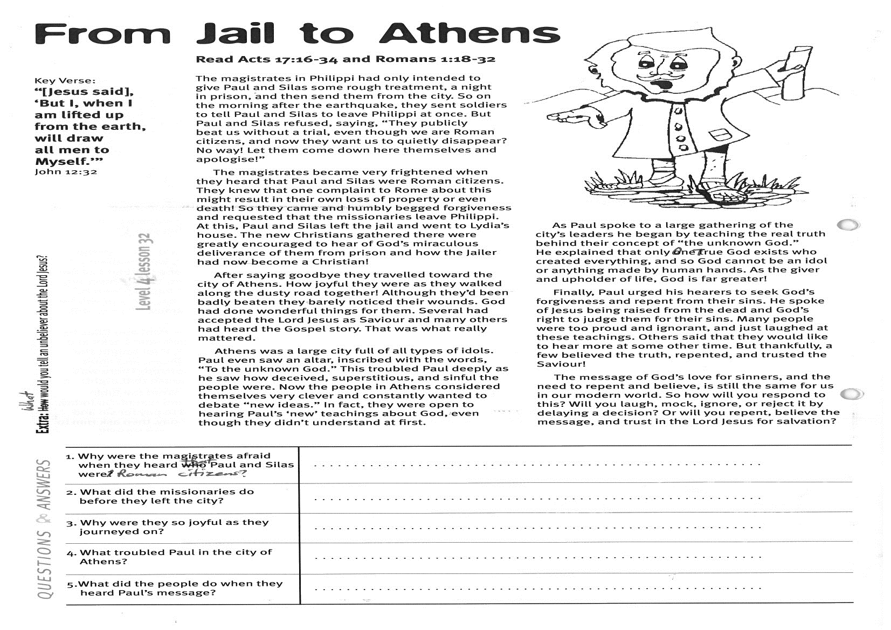
From Jail to Athens
Key Verse:
“[Jesus said], ‘But I, when I am lifted up from the earth, will draw all men to Myself’.“
John 12:32

Read Acts 17:16-34
and Romans 1:18-32
The magistrates in Philippi had only intended to give Paul and Silas some rough treatment, a night in prison, and then send them from the city. So on the morning after the earthquake, they sent soldiers to tell Paul and Silas to leave Philippi at once. But Paul and Silas refused, saying, “They publicly beat us without a trial, even though we are Roman citizens, and now they want us to quietly disappear? No way! Let them come down here themselves and apologise!” (Acts 16:37)
The magistrates became very frightened when they heard that Paul and Silas were Roman citizens. They knew that one complaint to Rome about this might result in their own loss of property or even death! So they came and humbly begged forgiveness and requested that the missionaries leave Philippi. At this, Paul and Silas left the jail and went to Lydia’s house. The new Christians gathered there were greatly encouraged to hear of God’s miraculous deliverance of them from prison and how the jailer had now become a Christian!
After saying goodbye they travelled toward the city of Athens. How joyful they were as they walked along the dusty road together! Although they’d been badly beaten they barely noticed their wounds. God had done wonderful things for them. Several had accepted the Lord Jesus as Saviour and many others had heard the Gospel story. That was what really mattered.
Athens was a large city full of all types of idols. Paul even saw an altar, inscribed with the words, “To the unknown God.” This troubled Paul deeply as he saw how deceived, superstitious, and sinful the people were.

1. Why were the magistrates afraid when they heard that Paul and Silas were Roman citizens?
2. What did the missionaries do before they left the city?
3. Why were they so joyful as they journeyed on?

4. What troubled Paul in the city of Athens?
5. What did the people do when they heard Paul’s message?
Extra: What would you tell an unbeliever about the Lord Jesus?
Level 4 lesson 32
QUESTIONS & ANSWERS
Now the people in Athens considered themselves very clever and constantly wanted to debate “new ideas.” In fact, they were open to hearing Paul’s ‘new’ teachings about God, even though they didn’t understand at first.
As Paul spoke to a large gathering of the city’s leaders he began by teaching the real truth behind their concept of “the unknown God.”
He explained that only One True God exists who created everything, and so God cannot be an idol or anything made by human hands. As the giver and upholder of life, God is far greater!
Finally, Paul urged his hearers to seek God’s forgiveness and repent from their sins. He spoke of Jesus being raised from the dead and God’s right to judge them for their sins. Many people were too proud and ignorant, and just laughed at these teachings. Others said that they would like to hear more at some other time. But thankfully, a few believed the truth, repented, and trusted the Saviour!
The message of God’s love for sinners, and the need to repent and believe, is still the same for us in our modern world. So how will you respond to this? Will you laugh, mock, ignore, or reject it by delaying a decision? Or will you repent, believe the message, and trust in the Lord Jesus for salvation?

Please complete and return by post to
PSSM Bible Discovery, 5/399 New North Rd, Kingsland, Auckland 1021 or scan & email to info@biblediscovery.org.nz

