A Riot in Ephesus
Key Verse:
“In this way the word of the Lord spread widely and grew in power.”
Acts 19:20

Read Acts 19:28-41;
and Psalm 115
Ephesus was a city of beautiful buildings and temples. Probably the most prominent and beautiful was a temple dedicated to the goddess Diana (also known as Artemis). Inside was a large idol image of Diana, which the people believed had once fallen from Jupiter. They believed also, that good luck would come to them if they wore little models of the image as charms, or set up such models in their homes (even today, some people still trust in all sorts of things like this to bring them “good luck”). Into this superstitious environment Paul came with the message of Jesus as the Saviour.
Paul faithfully preached the message of the Gospel and God worked many miracles through him among the people. Many believed and trusted Christ as Saviour. Of course, this meant they no longer visited the temple of Diana or worshipped her idol image. The silversmiths, who made money by selling images of Diana, were naturally upset about this; because they were now selling fewer Diana idols and making less money!
Finally, a man named Demetrius, called a meeting of silversmiths. In a stirring speech, he reminded them that not only in Ephesus, but throughout the whole province, Paul had turned people away from their religion. The trades of silversmiths and others were in danger of being ruined, he claimed; and the worship of Diana in danger of dying out. As he spoke, the tradesmen gathered there began chanting furiously, “Great is Diana of the Ephesians!” Others joined in, chanting it over and over until the crowd was in a frenzied uproar and began to riot in the streets.

The wild mob was desperate to find Paul but could not find him. However, they came across two other Christians called Gaius and Aristarchus, who they dragged roughly into the great open-air theatre, which could hold over twenty thousand people. There the huge mob milled around for hours chanting loudly, “Great is Diana of the Ephesians!” In due course, Paul heard what was happening and wanted to go and face the crowd, but his fellow Christians wisely urged him not to. The crowd was so out of control that many didn’t even know what they were rioting about! Poor superstitious deceived people, working so hard to protect their ‘god’ against the power of the true God! They could not see that their ‘goddess’ Diana was in fact, powerless. This idol could do nothing for herself, let alone help anyone else!
Finally, the mayor of the town arrived on the scene. Quietening the crowd, he reminded them that it was well-known how Ephesus honoured Diana, so there was no need to make so much noise about it, nor do anything foolish. The men who they were so desperate to punish had “neither robbed temples nor blasphemed our goddess.” If the people had any grievances against them they should take their charges to court. He warned them that if the riot was reported to Rome, the Emperor would have the people punished as “we would not be able to account for this commotion, since there is no reason for it!”
At his words, the crowd finally broke up and everyone went home. What a stir it must have been! How blind the devil can make people to the foolishness of idol worship. But we know that many in Ephesus left their pagan, superstitious beliefs to follow Jesus Christ; and a Christian church was formed.

1. What story did the people of Ephesus believe about their goddess Diana?
2. What did Paul do so faithfully in Ephesus?
3. What made the silversmiths so angry?
4. What was the mayor of the town afraid of?
5. What was the result of Paul’s preaching in Ephesus?
My Name is _____________________________________________ Age ___________
Extra: Draw or write about some modern idols.
Level 4 lesson 33
QUESTIONS & ANSWERS
Level 3 lesson 1
Key Verse:
“Jesus said, ‘I tell you the truth, unless a man is born again, he cannot see the kingdom of God.’”
John 3:3
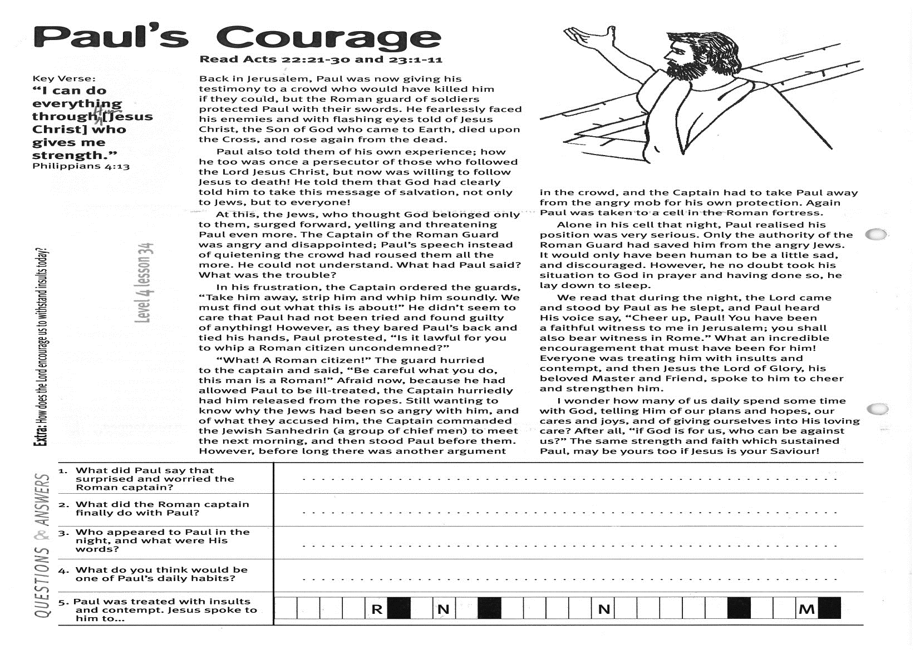
Paul’s Courage
Key Verse:
“I can do everything through Him [Jesus Christ] who gives me strength.”
Philippians 4:13
Read Acts 22:21-30
and Acts 23:1-11
Back in Jerusalem, Paul was now giving his testimony to a crowd who would have killed him if they could, but the Roman guard of soldiers protected Paul with their swords. He fearlessly faced his enemies and with flashing eyes told of Jesus Christ, the Son of God who came to earth, died upon the cross, and rose again from the dead.
Paul also told them of his own experience; how he too was once a persecutor of those who followed the Lord Jesus Christ, but now was willing to follow Jesus, even to death! He told them that God had clearly told him to take this message of salvation, not only to the Jews, but to everyone!
At this, the Jews, who thought God belonged only to them, surged forward, yelling and threatening Paul even more. The Captain of the Roman Guard was angry and disappointed; Paul’s speech instead of quietening the crowd had roused them all the more. He could not understand. What had Paul said? What was the trouble?
In his frustration, the Captain ordered the guards, “Take him away, strip him and whip him soundly. We must find out what this is about!” He didn’t seem to care that Paul had not been tried or found guilty of anything! However, as they bared Paul’s back and tied his hands, Paul protested, “Is it lawful for you to whip a Roman citizen, who has not been proven guilty?”
“What! A Roman citizen!” The guard hurried to the captain and said, “Be careful what you do, this man is a Roman!” Afraid now, because he had allowed Paul to be ill-treated, the Captain hurriedly had him released from the ropes.
1. What did Paul say that surprised and worried the Roman Captain?
2. What did the Roman Captain finally do with Paul?
3. Who appeared to Paul in the night, and what did He say?
4. What do you think would be one of Paul’s daily habits?
5. Paul was treated with insults and contempt. Jesus spoke to him to…
   |  |  |  | R |  |  | N |  |  |  |  |  |  | N
   | H
Extra: How does the Lord encourage us to withstand insults today?
Level 4 lesson 34
QUESTIONS & ANSWERS
Still wanting to know why the Jews had been so angry with him, and of what they accused him, the Captain commanded the Jewish Sanhedrin (a group of chief men) to meet the next morning, and then stood Paul before them. However, before long there was another argument in the crowd, and the Captain had to take Paul away from the angry mob for his own protection. Again Paul was taken to a cell in the Roman fortress.
Alone in his cell that night, Paul realised his position was very serious. Only the authority of the Roman Guard had saved him from the angry Jews. It would only have been human to be a little sad, and discouraged. However, he no doubt took his situation to God in prayer and having done so, he lay down to sleep.
We read that during the night, the Lord came and stood by Paul as he slept, and Paul heard His voice say, “Cheer up, Paul! You have been a faithful witness to me in Jerusalem; you shall also bear witness in Rome.” What an incredible encouragement that must have been for him! Everyone was treating him with insults and contempt, and then Jesus the Lord of Glory, his beloved Master and Friend, spoke to him to cheer and strengthen him.
I wonder how many of us daily spend some time with God, telling Him of our plans and hopes, our cares and joys, and of giving ourselves into His loving care? After all, “if God is for us, who can be against us?” The same strength and faith which sustained Paul, may be yours too if Jesus is your Saviour!

QUESTIONS:

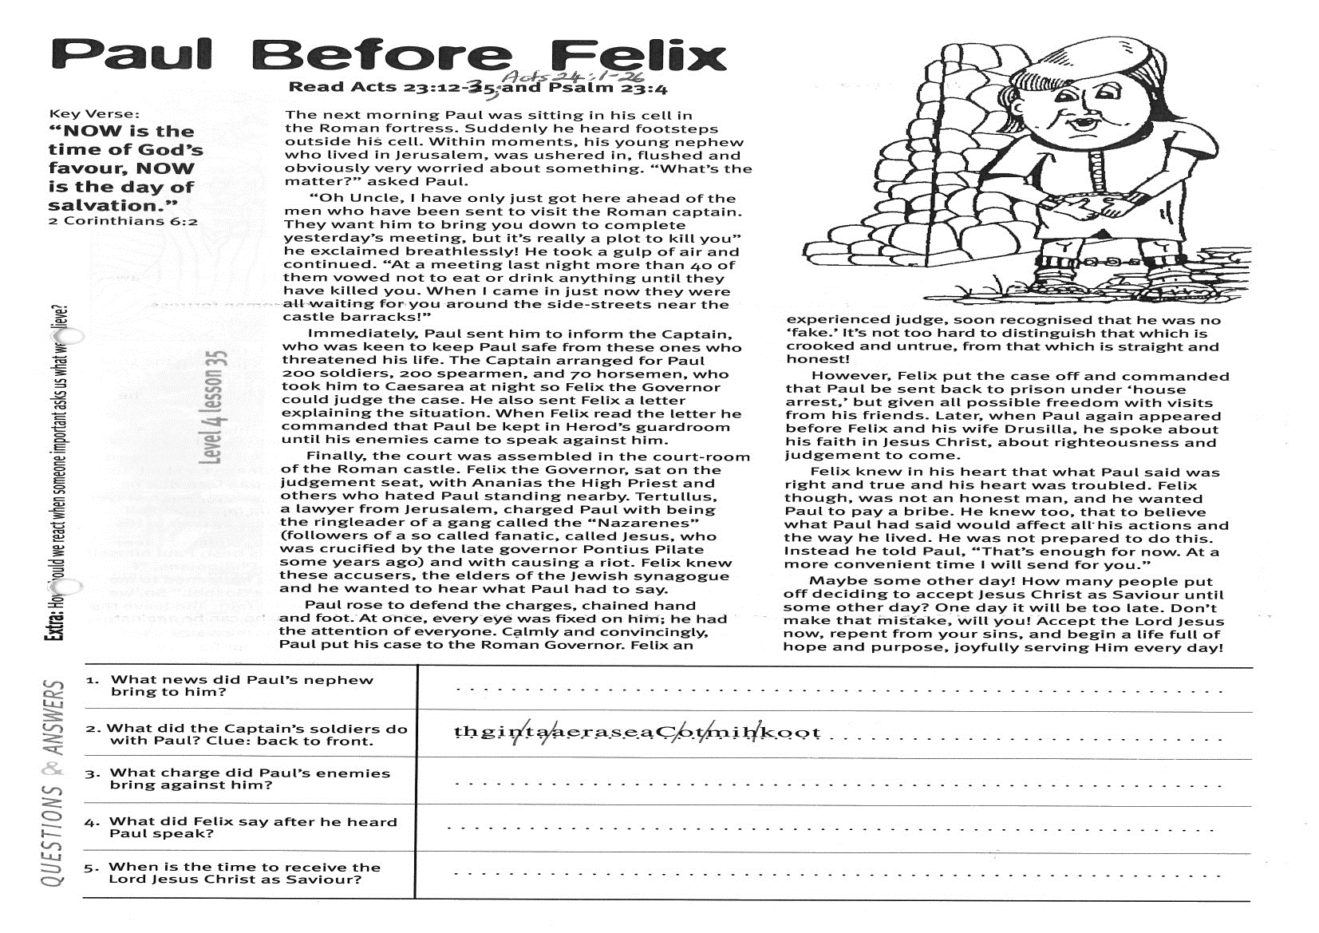
Key Verse:
“NOW is the time of God’s favour, NOW is the day of salvation.”
2 Corinthians 6:2
Read Acts 23:12-35; Acts 24
and Psalm 23:4
The next morning Paul was sitting in his cell in the Roman fortress. Suddenly he heard footsteps outside his cell. Within moments, his young nephew who lived in Jerusalem, was ushered in, flushed and obviously very worried about something. “What’s the matter?” asked Paul.
“Oh Uncle, I have only just got here ahead of the men who have been sent to visit the Roman captain. They want him to bring you down to complete yesterday’s meeting, but it’s really a plot to kill you”, he exclaimed breathlessly! He took a gulp of air and continued. “At a meeting last night more than 40 of them vowed not to eat or drink anything until they have killed you. When I came in just now they were all waiting for you around the side-streets near the castle barracks!”
Immediately, Paul sent him to inform the Captain, who was keen to keep Paul safe from these ones who threatened his life. The Captain arranged for 200 soldiers, 200 spearmen, and 70 horsemen, who took Paul to Caesarea at night, so Felix the Governor could judge the case. He also sent Felix a letter explaining the situation. When Felix read the letter he commanded that Paul be kept in Herod’s guardroom until his enemies came to speak against him.
Finally, the court was assembled in the court-room of the Roman castle. Felix the Governor, sat on the judgement seat, with Ananias the High Priest and others who hated Paul standing nearby. Tertullus, a lawyer from Jerusalem, charged Paul with being the ringleader of a gang called the “Nazarenes” (followers of a so-called fanatic, called Jesus, who was crucified by the late governor Pontius Pilate some years ago) and with causing a riot. Felix knew these accusers, the elders of the Jewish synagogue and he wanted to hear what Paul had to say.
Paul Before Felix
1. What news did Paul’s nephew bring to him?
2. What did the Captain’s soldiers do with Paul? (Clue: back to front) | thgin ta aeraseaC ot mih koot
3. What charge did Paul’s enemies bring against him?
4. What did Felix say after he heard Paul speak?

5. When is the time to receive the Lord Jesus Christ as Saviour?
Extra: How should we react when someone important asks us what we believe?

Level 4 lesson 35
QUESTIONS & ANSWERS
Paul rose to defend the charges, chained hand and foot. At once, every eye was fixed on him; he had the attention of everyone. Calmly and convincingly, Paul put his case to the Roman Governor. Felix, an experienced judge, soon recognised that he was no ‘fake.’ It’s not too hard to distinguish that which is crooked and untrue, from that which is straight and honest!
However, Felix put the case off and commanded that Paul be sent back to prison under ‘house arrest,’ but given all possible freedom with visits from his friends. Later, when Paul again appeared before Felix and his wife Drusilla, he spoke about his faith in Jesus Christ, about righteousness and judgement to come.
Felix knew in his heart that what Paul said was right and true and his heart was troubled. Felix though, was not an honest man, and he wanted Paul to pay a bribe. He knew too, that to believe what Paul had said would affect all his actions and the way he lived. He was not prepared to do this. Instead he told Paul, “That’s enough for now. At a more convenient time I will send for you.”
Maybe some other day! How many people put off deciding to accept Jesus Christ as Saviour until some other day? One day it will be too late! Don’t make that mistake, will you? Accept the Lord Jesus now, repent from your sins; and begin a life full of hope and purpose, joyfully serving Him every day!

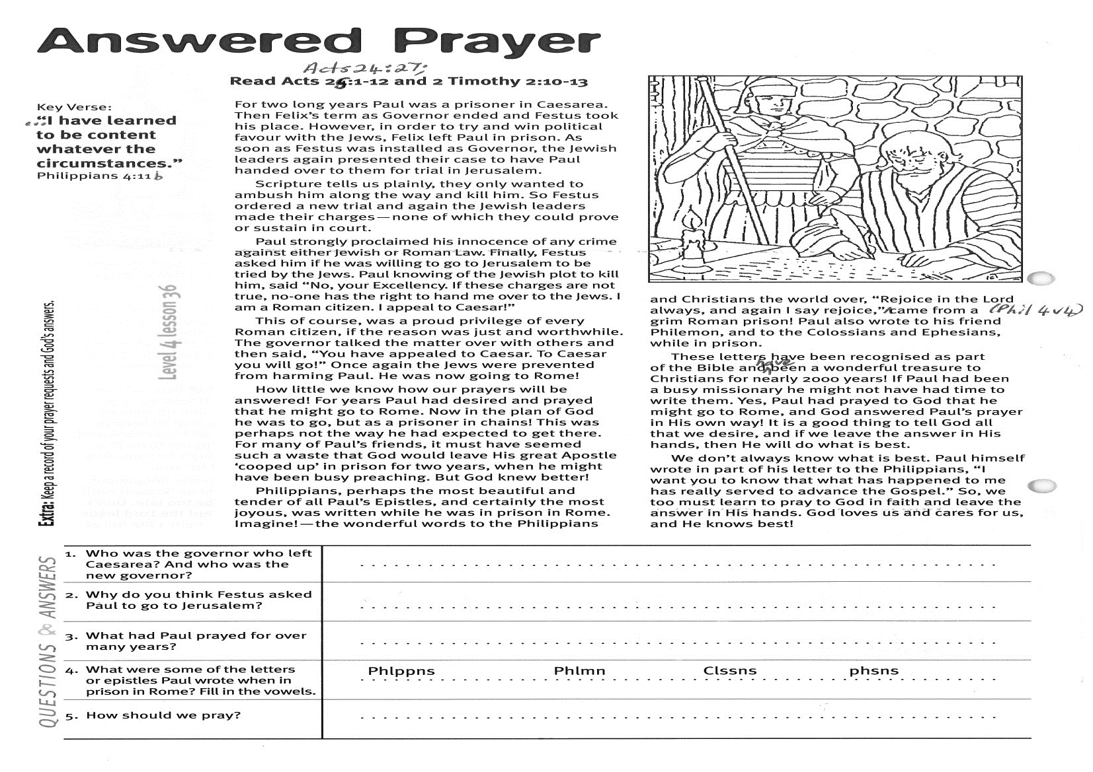
Answered Prayer
Key Verse:
“…I have learned to be content whatever the circumstances.”
Philippians 4:11b
Read Acts 24:27; 25:1-12
and 2 Timothy 2:10-13
For two long years Paul was a prisoner in Caesarea. Then Felix’s term as Governor ended and Festus took his place. However, in order to try and win political favour with the Jews, Felix left Paul in prison. As soon as Festus was installed as Governor, the Jewish leaders again presented their case to have Paul handed over to them for trial in Jerusalem.
Scripture tells us plainly, they only wanted to ambush him along the way and kill him. So Festus ordered a new trial and again the Jewish leaders made their charges - none of which they could prove or sustain in court.
Paul strongly proclaimed his innocence of any crime against either Jewish or Roman Law. Finally, Festus asked him if he was willing to go to Jerusalem to be tried by the Jews. Paul, knowing of the Jewish plot to kill him, said “No, your Excellency. If these charges are not true, no-one has the right to hand me over to the Jews. I am a Roman citizen. I appeal to Caesar!”
This of course, was a proud privilege of every Roman citizen, if the reason was just and worthwhile. The governor talked the matter over with others and then said, “You have appealed to Caesar. To Caesar you will go!” Once again the Jews were prevented from harming Paul. He was now going to Rome!
How little we know how our prayers will be answered! For years Paul had desired and prayed that he might go to Rome. Now in the plan of God he was to go, but as a prisoner in chains! This was perhaps not the way he had expected to get there.
1. (a) Who was the governor who left Caesarea? (b) Who was the new governor? | (a) __ __ __ __ __ (b) __ __ __ __ __ __
2. Why do you think Festus asked Paul to go to Jerusalem?
3. What had Paul prayed for over many years?

4. What were some of the letters or epistles Paul wrote when in prison in Rome? | (Add vowels) Phlppns Phlmn Clssns phsns  Answers:
5. How should we pray?
Please complete and return by post to
PSSM Bible Discovery, 5/399 New North Rd, Kingsland, Auckland 1021 or scan & email to info@biblediscovery.org.nz

Extra: Keep a record of your prayer requests and God’s answers.
Level 4 lesson 36
QUESTIONS & ANSWERS
For many of Paul’s friends, it must have seemed such a waste that God would leave His great Apostle ‘cooped up’ in prison for two years, when he might have been busy preaching. But God knew better!
Philippians, perhaps the most beautiful and tender of all Paul’s Epistles, and certainly the most joyous, was written while he was in prison in Rome. Imagine! The wonderful words to the Philippians and Christians the world over, “Rejoice in the Lord always, and again I say rejoice,” (Philippians 4:4) came from a grim Roman prison! Paul also wrote to his friend Philemon, and to the Colossians and Ephesians, while in prison.
These letters have been recognised as part of the Bible and have been a wonderful treasure to Christians for over 2000 years! If Paul had been a busy missionary he might not have had time to write them. Yes, Paul had prayed to God that he might go to Rome, and God answered Paul’s prayer in His own way! It is a good thing to tell God all that we desire, and if we leave the answer in His hands, then He will do what is best.
We don’t always know what is best. Paul himself wrote in part of his letter to the Philippians, “I want you to know that what has happened to me has really served to advance the Gospel.” So, we too must learn to pray to God in faith and leave the answer in His hands. God loves us and cares for us, and He knows best!

