**October 2017  
Bible Readings**

DATE BOOK REFERENCE

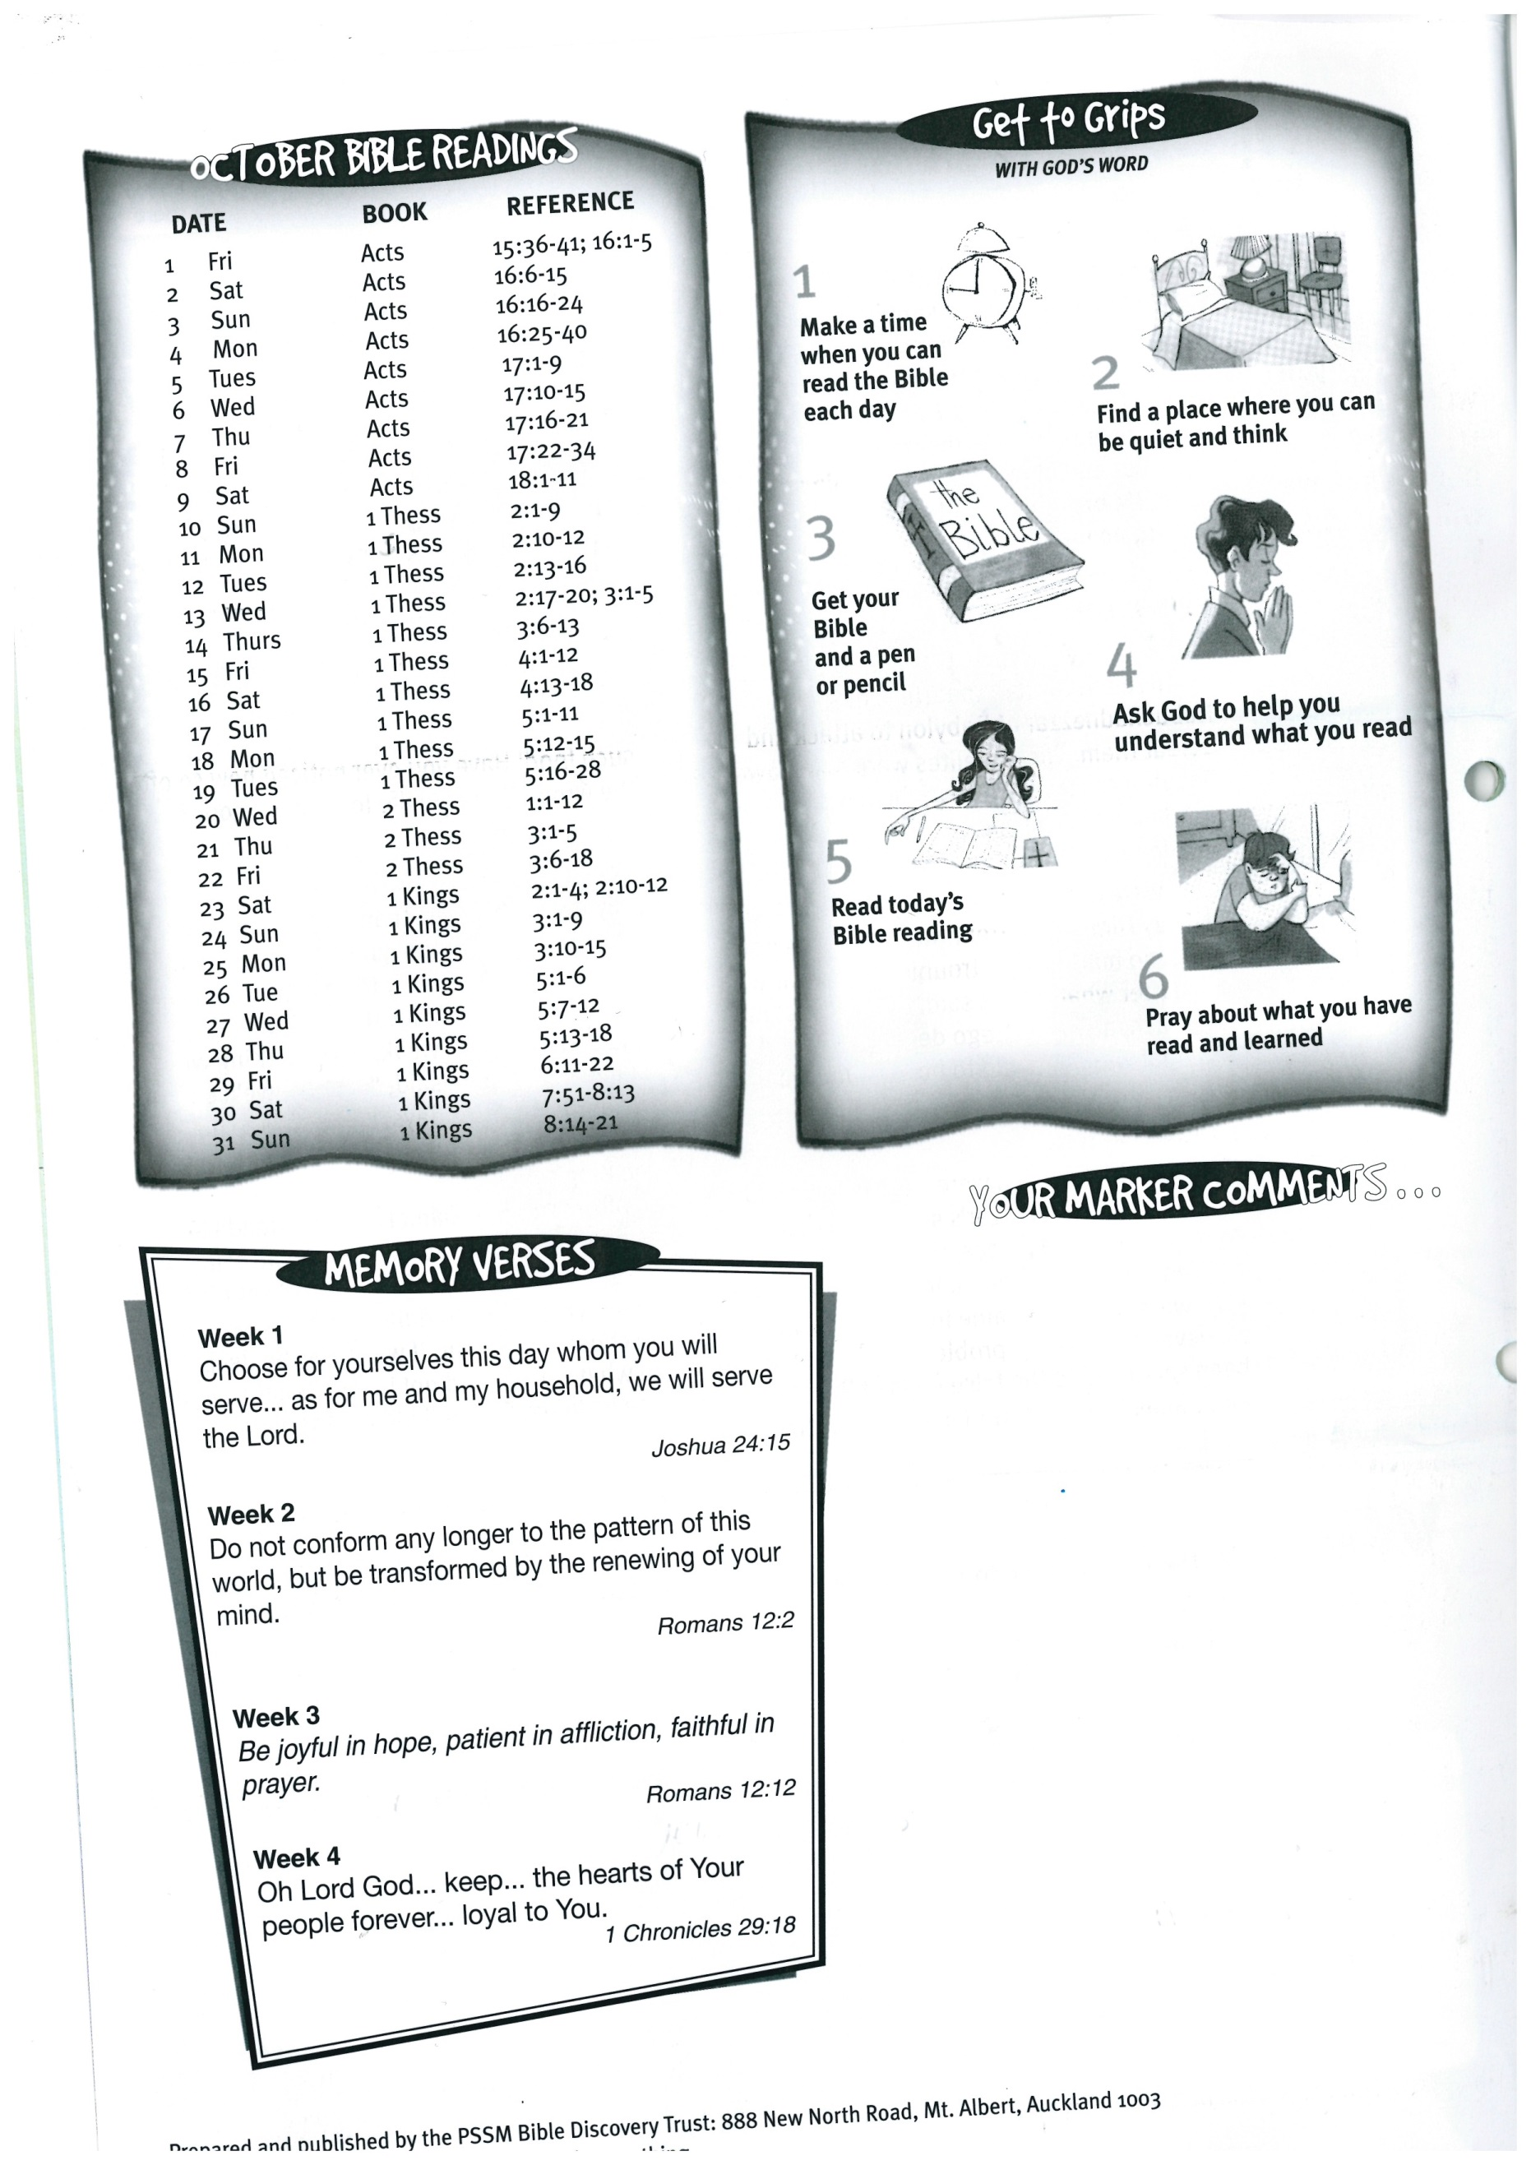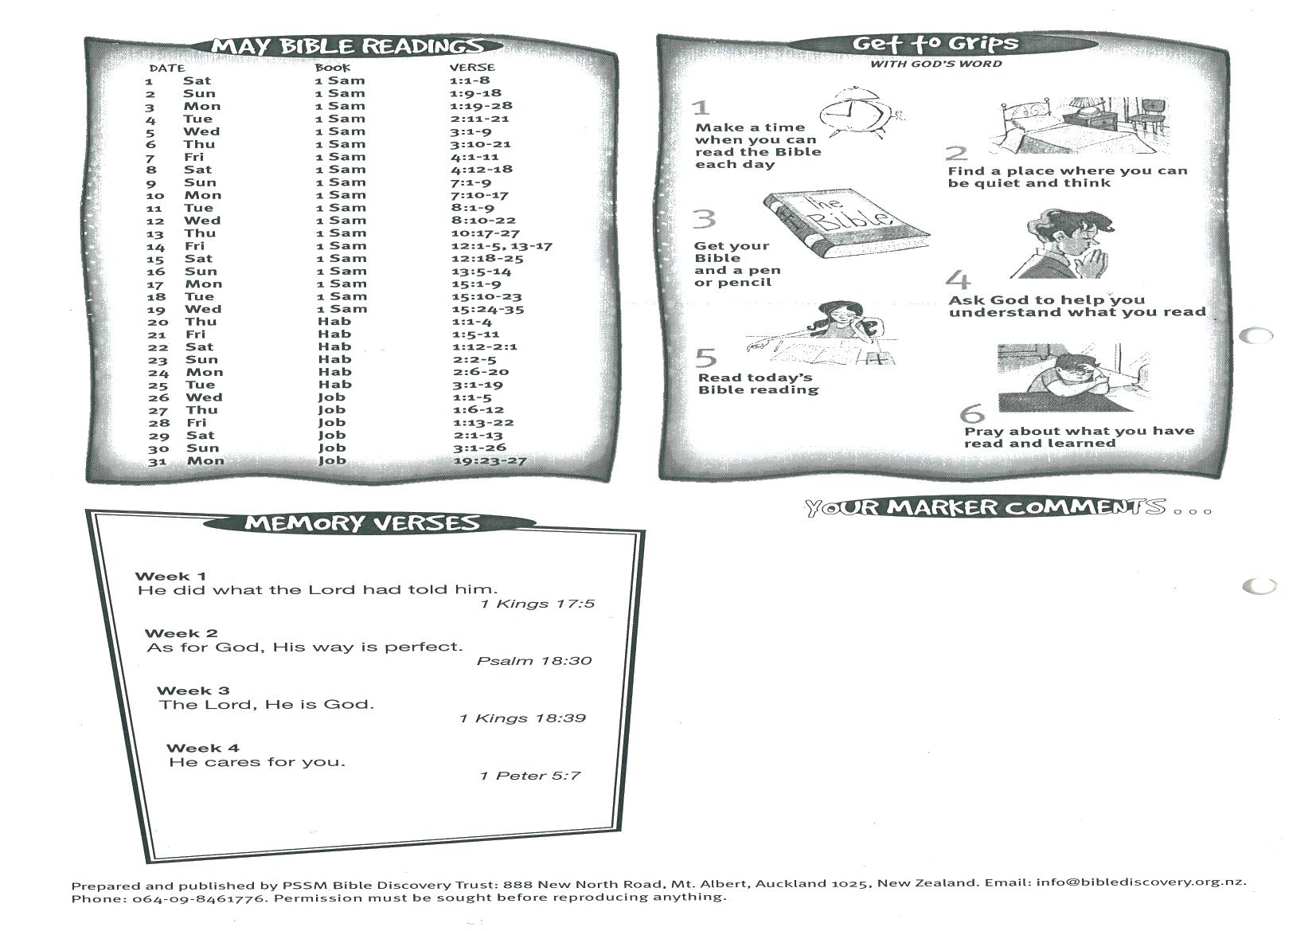



**1 Kings 7:51-8:13  
 1 Kings 8:14-21**

**29  
30 Luke 10:38-42  
31 Luke 7:18-23**

**31**