○

Their family and friends thought they should name the baby after his father. They could not understand why he should be called John. But Zechariah and Elizabeth knew what God had told them, and they obeyed Him. Finally, Zechariah took a pen and wrote, “His name shall be John”, just as the angel had said. Straight away Zechariah was able to speak again!

God told them that their son would grow up to be a preacher. He would turn the hearts of people to the Lord Jesus. They were very happy. Zechariah praised God and said to his little boy, “You will be called a prophet of the Most High, for it will be your work to prepare the way for the Son of God.”

The little boy grew up and became known as John the Baptist. What a wonderful work he had to do telling people about the Lord Jesus. Yes, Jesus was the one who came to earth from Heaven, died for sinners, and rose from the dead after three days.

Jesus now offers salvation to all who believe! The Bible says that everyone who believes in Jesus will have eternal life (John 3:15)! Will you believe in Jesus and cry out to God to forgive all of your sins? Will you turn your heart toward Jesus and follow Him every day?

**Read: Luke 1:5-22 and 57-66**Wow! It’s nearly Christmas again. Isn’t that exciting! In our lessons this month, we’re going to learn how Jesus, the Son of God, came to earth as a baby. This is the REAL story of Christmas...

When Herod was King of Judea, there was an old priest in God’s Temple. His name was Zechariah. He and his wife Elizabeth were good people who loved God. Elizabeth was the cousin of Mary, Jesus’ mother. However, the old couple were very sad because they had no children. One day an angel of God appeared to Zechariah when he was working in the Temple. The angel told him that he and Elizabeth would have a son, and they were to name him John.

What a surprise! Zechariah could hardly believe it. “I am an old man and my wife is old too,” he said to the angel, “Give me a sign so I know this is true.” The angel replied, “I will give you a sign. Because you did not believe me, you will not be able to speak until the baby is born.” And that is exactly what happened!

Just as the angel had promised, God gave Elizabeth a son. When he was eight days old it was time to name him.

Key Verse:  
**“Do not be ashamed to testify about our Lord.”**

2 Timothy 1:8

**John the Baptist Prepares the Way**

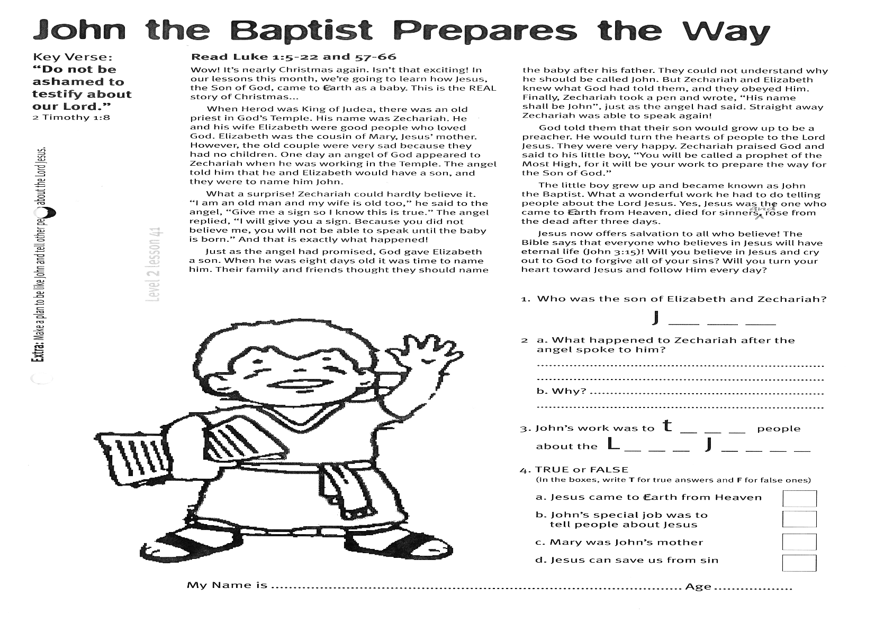

**Extra:** Make a plan to be like John and tell other people about the Lord Jesus.

**Level 2 lesson 41**

1. Who was the son of Elizabeth and Zechariah?  
 **__ __ __ __**

2. What happened to Zechariah after the angel spoke to him, and why?  
………………………………………………………………………………………………………………………………………………………………………………………………

3. John’s work was to **t __ __ __** people about the  
**L __ __ __ J __ __ __ __**

My Name is________________________________________ Age ______

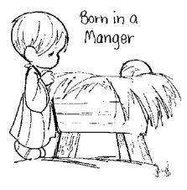

**Read Luke 2:1-7**An angel of God came to Mary with a wonderful message. Like Elizabeth, she too was to have a very special baby. He would be the Son of God! She and her husband Joseph were to name Him Jesus. Mary was so excited!

Soon it was time for the baby to be born. But Caesar Augustus (the Roman Emperor) told everyone to go to the town where their family had first lived, so he could count all the people in a census. This meant Mary and Joseph had to go to Bethlehem, because that was the home of their great ancestor King David.

It was a long journey and Mary had to ride on a donkey. It was evening when they arrived at Bethlehem. They tried to find a place to sleep for the night, but the city was crowded. There was no room for them anywhere! Finally, one innkeeper felt sorry for the young couple. He told them they could stay in the stable behind his inn (motel). It was not a very nice place to spend the night, but at least they had some shelter.

Key Verse:  
**“Jesus… will save His people from their sins.”**

Matthew 1:21

**The Birth of the Lord Jesus**

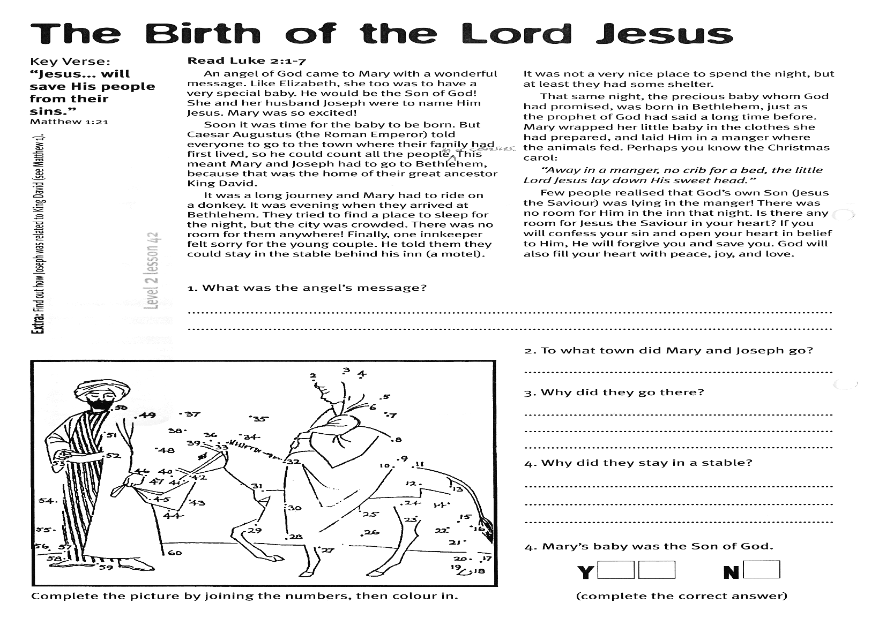

That same night, the precious baby whom God had promised, was born in Bethlehem, just as the prophet of God had said a long time before. Mary wrapped her little baby in the clothes she had prepared, and laid Him in a manger where the animals fed.

Perhaps you know the Christmas carol:

*“Away in a manger, no crib for a bed, the little Lord Jesus lay down His sweet head.”*

Few people realised that God’s own Son (Jesus the Saviour) was lying in the manger! There was no room for Him in the inn that night. Is there any room for Jesus the Saviour in your heart? If you will confess your sin and open your heart in belief to Him, He will forgive you and save you. God will also fill your heart with peace, joy, and love.

2. To what town did Mary and Joseph go?  
 __ __ __ __ __ __ __ __ __

3. Why did they go there?  
………………………………………………………………………………………………………………………………………..

4. Why did they stay in a stable?  
…………………………………………………………………………………………………………………………………………

5. Mary’s baby was the Son of God  
(Complete the correct answer)  
 **Y □ □ N □**

1. What was the angel’s message?  
…………………………………………………………………………………………………………………………………

**Extra:** Find out how Joseph was related to King David (See Matthew 1)

**Level 2 lesson 42**

The shepherds rubbed their eyes in wonder; had they all been dreaming? Excitedly they talked about the amazing sight they had just seen. They could hardly wait to go and see the baby for themselves. As quickly as they could, they ran into Bethlehem to find the Saviour. There in the stable (just as the angel had said) they found the little baby, lying in a manger; with His mother Mary and Joseph watching over Him.

Silently, the shepherds knelt down. They bowed their heads and worshipped baby JESUS. Later, when they returned to their work, they were praising God. They couldn’t forget the joy of seeing the SAVIOUR, or the angel’s wonderful words. Mary’s heart was glad too, as she sat with her baby son. She would always remember the visit of the shepherds, who came to worship their Saviour King. This Christmas, let us remember that Jesus also came to be our Saviour and Lord, also.

**Read: Luke 2:8-20**  
On the night JESUS was born in Bethlehem, some shepherds were watching over their sheep in the fields. Suddenly a bright, shining angel appeared before them! The shepherds were afraid, but he said kindly to them, “Don’t be afraid. I bring you good news of great joy that will be for all the people. Today in the town of David, a Saviour has been born to you; He is Christ the Lord. This will be a sign for you; you will find the child wrapped in baby clothes and lying in a manger.” The shepherds were no longer afraid. The angel’s news cheered them up and made them very happy.

As the angel finished speaking, it suddenly seemed as if Heaven opened; the whole sky was full of shining angels, singing and praising God! What a wonderful message they sang, “Glory to God in the highest, and on earth peace to men on whom His favour rests.” Then as suddenly as they had appeared, they were gone and the sky was dark again.

Key Verse:  
**“Glory to God in the highest and on earth peace to men on whom His favour rests.”**

Luke 2:14

**Wonderful News!**

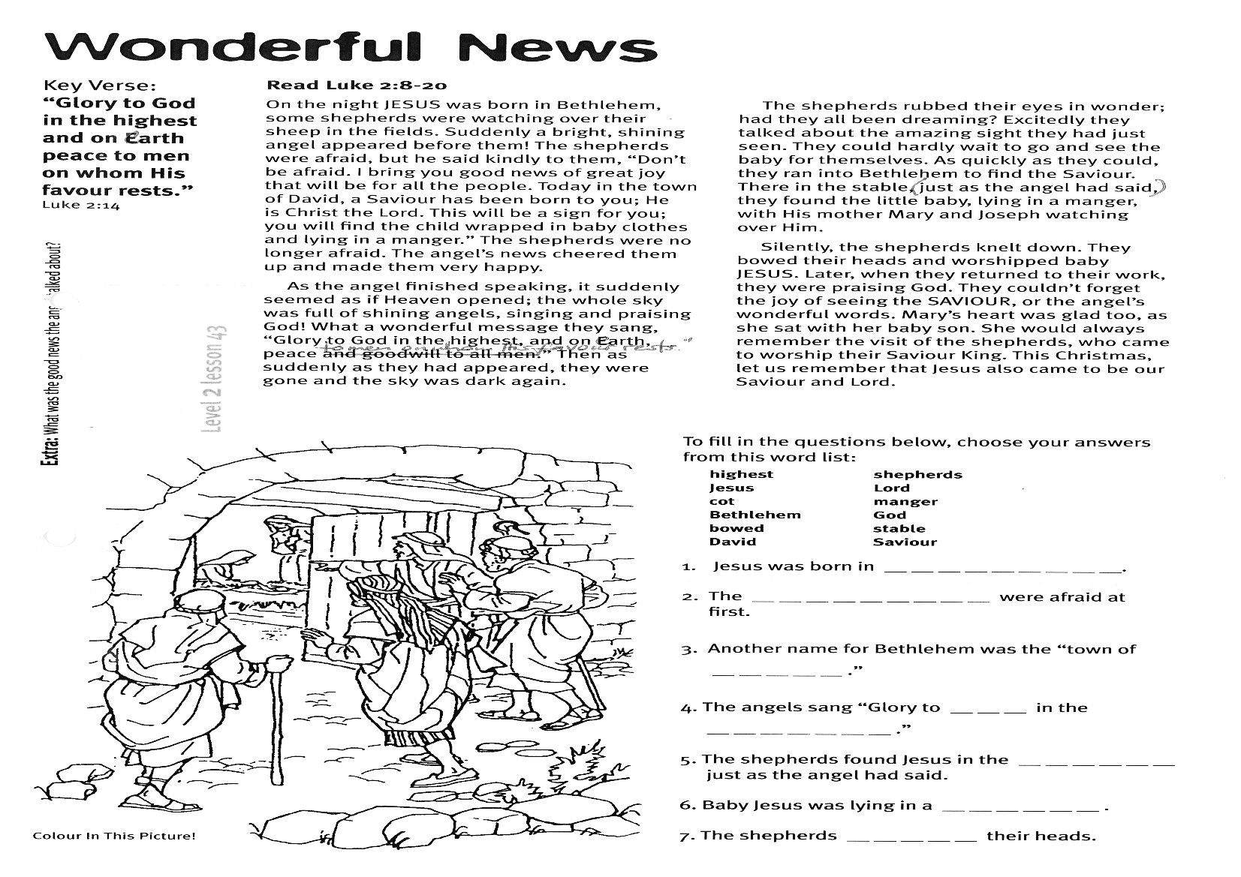

To fill in the questions below, choose your answers from this word list (Note: some words are **not** used)  
**highest shepherds Jesus Lord cot manger Bethlehem God bowed stable David Saviour**

**1.** Jesus was born in __ __ __ __ __ __ __ __ __  
**2.** The __ __ __ __ __ __ __ __ __ were afraid at first.  
**3.** Another name for Bethlehem was the ‘town of __ __ __ __ __.”  
**4.** The angels sang “Glory to __ __ __ in the __ __ __ __ __ __ __.”  
**5.** The shepherds found Jesus in the __ __ __ __ __ __ just as the angel had said.  
**6.** Baby Jesus was lying in a __ __ __ __ __ __.  
**7.** The shepherds __ __ __ __ __ their heads.

**Extra:** What was the good news the angel talked about?

**Level 2 lesson 43**

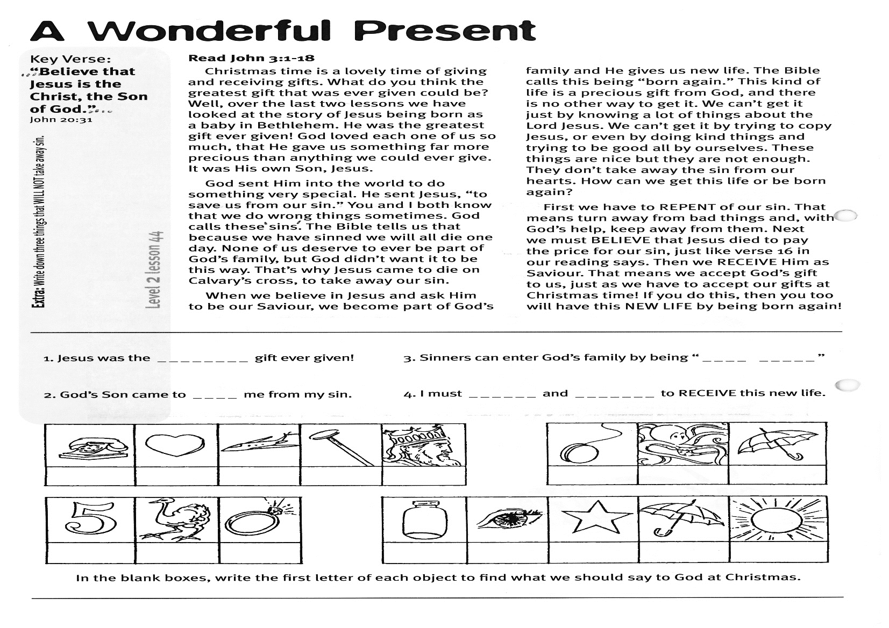

Please complete and return by post to: **PSSM Bible Discovery, 5/399 New North Rd, Kingsland, Auckland 1021**or scan & email to **info@biblediscovery.org.nz**

**(PLEASE NOTE: THERE ARE NO LESSONS IN JANUARY – THE NEXT ONES WILL BE FEBRUARY 2018)**

1. Jesus was the __ __ __ __ __ __ __ __ gift ever given!  
2. God’s Son came to __ __ __ __ me from my sin.  
3. Sinners can enter God’s family by being “__ __ __ __ __ __ __ __ __”  
4. I must __ __ __ __ __ __ and __ __ __ __ __ __ __ to RECEIVE this new life.

The Bible calls this being “born again.” This kind of life is a precious gift from God, and there is no other way to get it. We can’t get it just by knowing a lot of things about the Lord Jesus. We can’t get it by trying to copy Jesus, or even by doing kind things and trying to be good all by ourselves. These things are nice but they are not enough. They don’t take away the sin from our hearts. How can we get this life or be born again?

First we have to REPENT of our sin. That means to turn away from bad things and, with God’s help, keep away from them. Next we must BELIEVE that Jesus died to pay the price for our sin, just like verse 16 in our reading says. Then we RECEIVE Him as Saviour. That means we accept God’s gift to us, just as we have to accept our gifts at Christmas time! If you do this, then you too will have this NEW LIFE by being born again!

**Level 2 lesson 44**

**Extra:** Write down three things that WILL NOT take away sin.

**Read John 3:1-18**

Christmas time is a lovely time of giving and receiving gifts. What do you think the greatest gift that was ever given could be? Well, over the last two lessons we have looked at the story of Jesus being born as a baby in Bethlehem. He was the greatest gift ever given! God loved each one of us so much, that He gave us something far more precious than anything we could ever give. It was His own Son, Jesus!

God sent Him into the world to do something very special. He sent Jesus “to save us from our sin.” You and I both know that we do wrong things sometimes. God calls these ‘sins’. The Bible tells us that because we have sinned we will all die one day. None of us deserve to ever be part of God’s family, but God didn’t want it to be this way. That’s why Jesus came to die on Calvary’s cross, to take away our sin.

When we believe in Jesus and ask Him to be our Saviour, we become part of God’s family and He gives us new life.

Key Verse: **“Believe that Jesus is the Christ, the Son of God.”**

John 20:31

**A Wonderful Present**