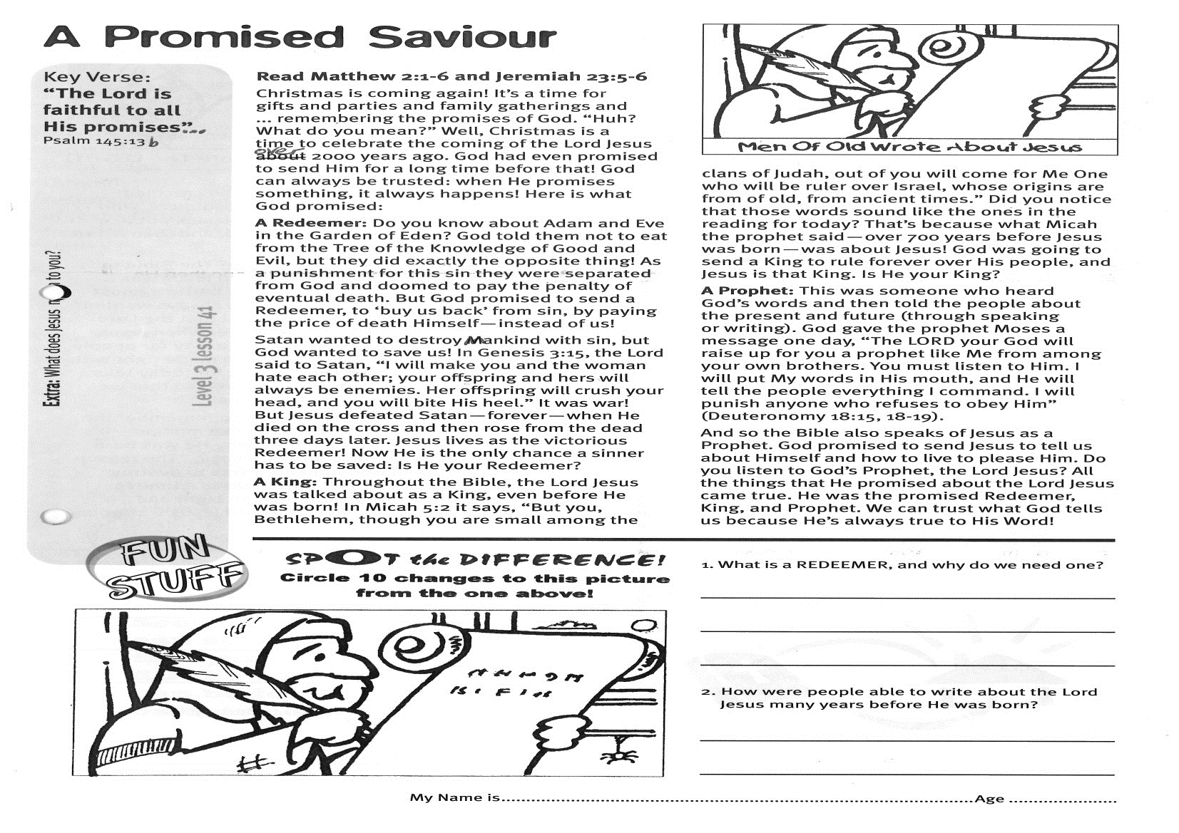

**A Promised Saviour**

**Read Matthew 2:1-6   
and Jeremiah 23:5-6**Christmas is coming again! It’s a time for gifts and parties and family gatherings and ... remembering the promises of God. “Huh? What do you mean?” Well, Christmas is a time to celebrate the coming of the Lord Jesus over 2000 years ago. God had even promised to send Him for a long time before that! God can always be trusted: when He promises something, it always happens! Here is what God promised:

**A Redeemer:** Do you know about Adam and Eve in the Garden of Eden? God told them not to eat from the Tree of the Knowledge of Good and Evil, but they did exactly the opposite thing! As a punishment for this sin they were separated from God and doomed to pay the penalty of eventual death. But God promised to send a Redeemer, to ‘buy us back’ from sin, by paying the price of death Himself - instead of us!

Satan wanted to destroy mankind with sin, but God wanted to save us! In Genesis 3:15, the Lord said to Satan, “I will make you and the woman hate each other; your offspring and hers will always be enemies. Her offspring will crush your head, and you will bite His heel.” It was war! But Jesus defeated Satan—forever—when He died on the cross and then rose from the dead three days later. Jesus lives as the victorious Redeemer! Now He is the only chance a sinner has to be saved: Is He your Redeemer?

**A King:** Throughout the Bible, the Lord Jesus was talked about as a King, even before He was born!

Key Verse:  
**“The Lord is faithful to all His promises…”**

Psalm 145:13b

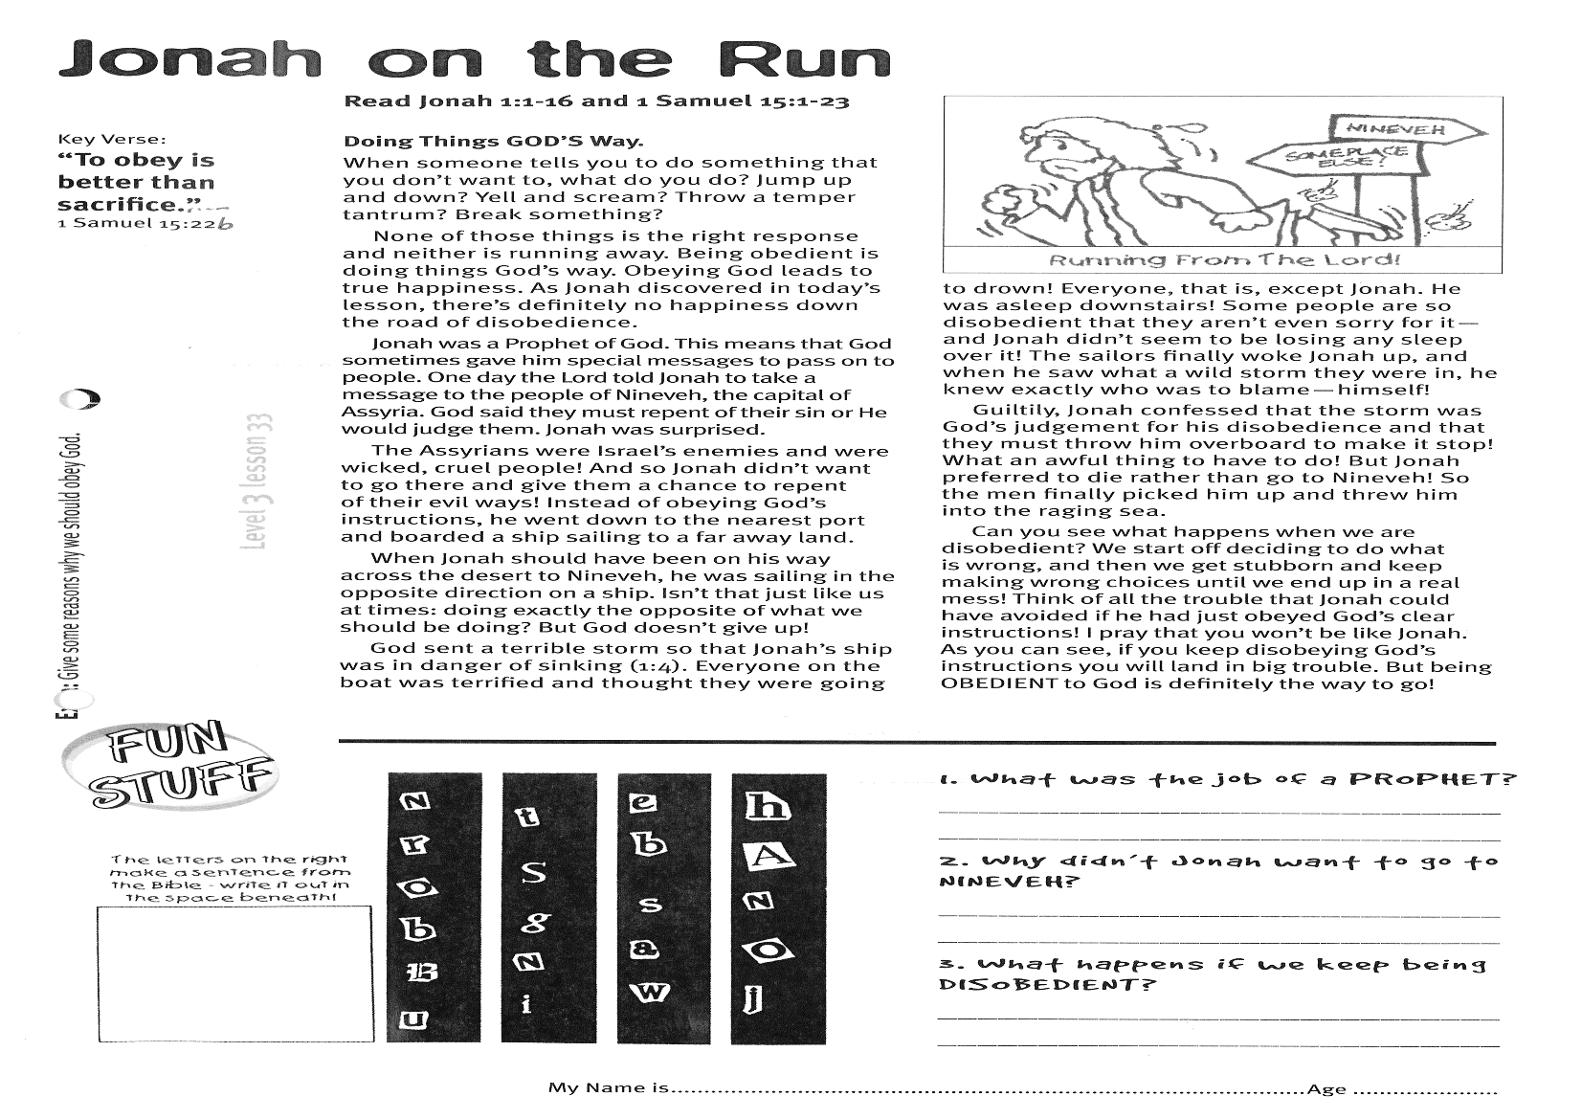

1. What is a REDEEMER, and why do we need one?

………………………………………………………………………………………………………………………………………………………………………………………………………………………………………

2. How were people able to write about the Lord Jesus many years before He was born?

………………………………………………………………………………………………………………………………………………………………………………………………………………………………………

**Extra:** What does Jesus mean to you?

In Micah 5:2 it says, “But you, Bethlehem, though you are small among the clans of Judah, out of you will come for Me One who will be ruler over Israel, whose origins are from of old, from ancient times.” Did you notice that those words sound like the ones in the reading for today? That’s because what Micah the prophet said (over 700 years before Jesus was born) was about Jesus! God was going to send a King to rule forever over His people, and Jesus is that King. Is He your King?

**A Prophet**: This was someone who heard God’s words and then told the people about the present and future (through speaking or writing). God gave the prophet Moses a message one day, “The LORD your God will raise up for you a prophet like Me from among your own brothers. You must listen to Him. I will put My words in His mouth, and He will tell the people everything I command. I will punish anyone who refuses to obey Him” (Deuteronomy 18:15,18,19).

And so the Bible also speaks of Jesus as a Prophet. God promised to send Jesus to tell us about Himself and how to live to please Him. Do you listen to God’s Prophet, the Lord Jesus? All the things that He promised about the Lord Jesus came true. He was the promised Redeemer, King, and Prophet. We can trust what God tells us because He’s always true to His Word!

**SPOT THE DIFFERENCE!  
Circle 10 changes to this picture from the one above!**

**Level 3 lesson 41**

My Name is ……………………………………………………… Age…………………



Key Verse:  
**“But He was pierced for our transgressions, He was crushed for our iniquities; the punishment that brought us peace was upon Him, and by His wounds we are healed.”**

Isaiah 53:5

**Read Isaiah 53:1-6   
and Acts 3:11-20**

**LIGHT versus DARKNESS:** The Bible tells us that God is Light (1 John 1:5) and Jesus also said He was the Light of the world (John 8:12). The Bible also tells us that the world is in darkness. That’s why people hate the Lord Jesus. Those who love the darkness hate the light because it shows up all the wrong things that they do.

Criminals don’t like the Police because they want to do what is wrong and the job of the Police is to make sure that everyone obeys the law! There is always a war between the light and the darkness, between good and evil. That’s because there is a war between God (who is holy and good) and the Devil (who hates everything good and loves evil)!

When the Lord Jesus was born on earth, He had enemies right from the start! King Herod wanted to kill Him because he had heard that Jesus was a king and he was jealous. When the Lord Jesus was a grown man, the Pharisees (who loved to act as if they were ‘holy’ and religious) hated Him, because Jesus pointed out to the people that they only pretended to be good. They became embarrassed and angry, and so made plans to have Him arrested andkilled!

After a while, a lot of people who used to follow Jesus began to hate Him because He didn’t do things exactly the way they thought He should have. They wanted an earthly king, but He was a Heavenly One, and so they wanted Him to be crucified!

**The Despised Saviour**

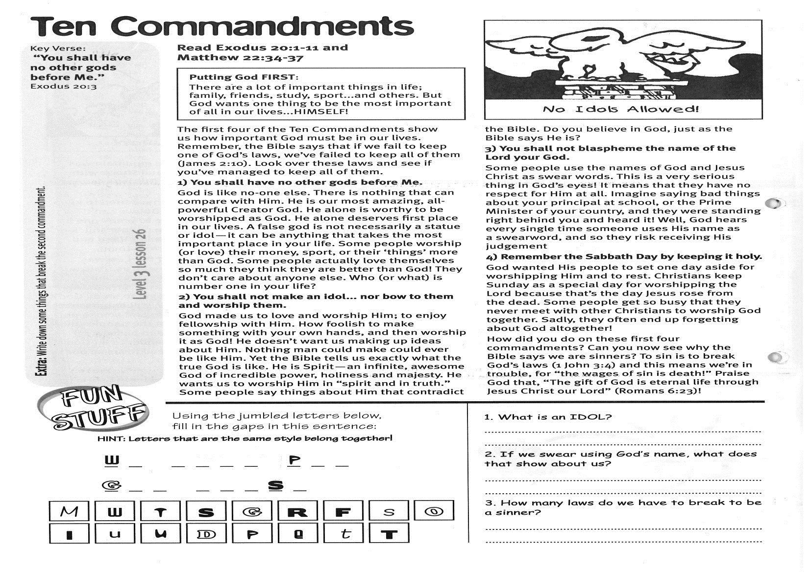

**Extra:** What does Christmas mean to you?

1. Why do some people hate what is right and true ?

………………………………………………………………………………………………………………………………………………………………………………………………………………………………………………………

2. How did the Lord Jesus destroy the devil’s work ?

………………………………………………………………………………………………………………………………………………………………………………………………………………………………………………………

**TRUE or FALSE?**

Then there were the Roman soldiers, who beat and whipped the Lord Jesus, put a crown of thorns on His head, and then nailed Him to the cross!

Did darkness win the battle? The Bible tells us that even though the Lord Jesus was crucified, He still won in His battle against the darkness! The Devil has always wanted to destroy the world (and all that the Lord had made) with SIN. However when Jesus died on the cross, He made a way for people to be SAVED FROM SIN and be made right with God the Father. Our reading for today tells us that the Lord Jesus suffered so that we could be saved from our sins!

Christmas isn’t just a time to remember the Lord Jesus as a little baby in a manger - It’s also a time to remember why He was born into this world. 1 John 3:8 says, “The reason the Son of God appeared was to destroy the Devil’s work.” Christmas is a time to remember the war between Light and Darkness, and how the Lord Jesus was going to win that war!

**Level 3 lesson 42**

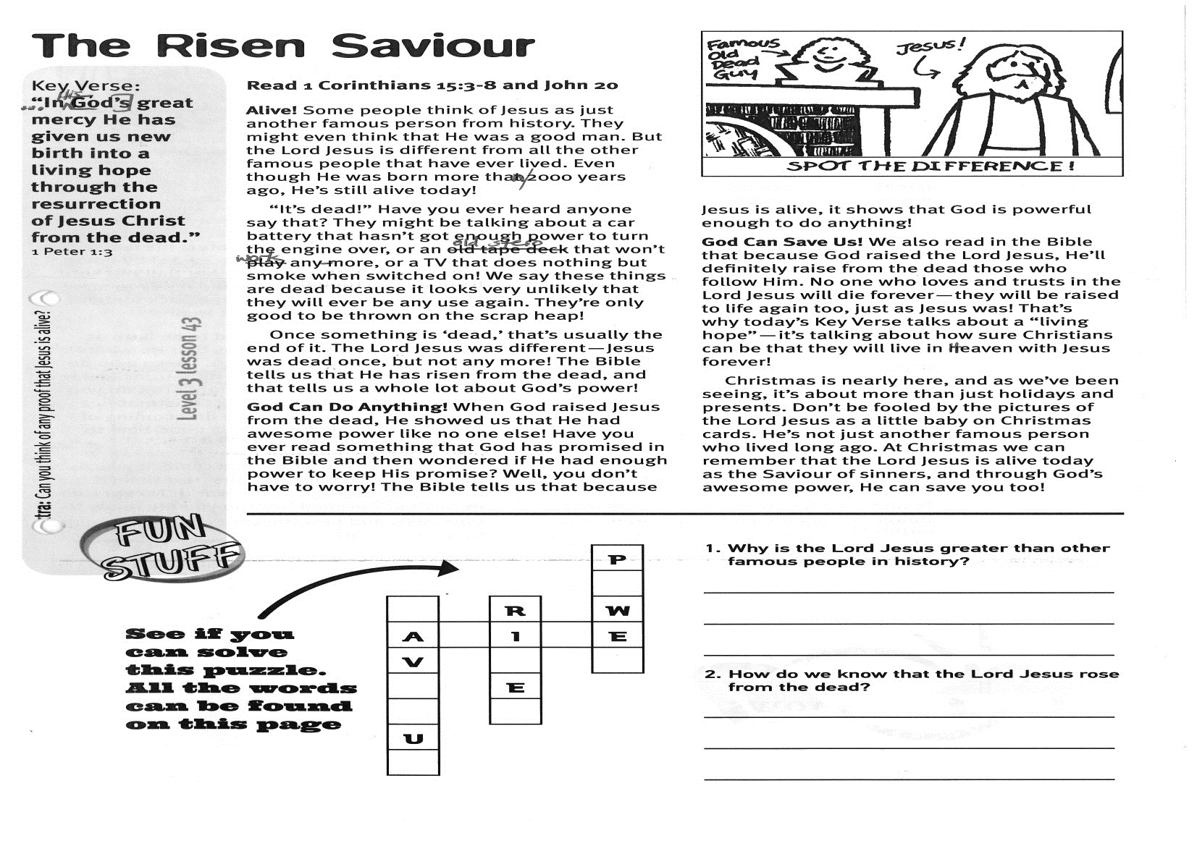

**Read 1 Corinthians 15:3-8  
and John 20**  
**Alive!** Some people think of Jesus as just another famous person from history. They might even think that He was a good man. But the Lord Jesus is different from all the other famous people that have ever lived. Even though He was born more than 2000 years ago, He’s still alive today!

“It’s dead!” Have you ever heard anyone say that? They might be talking about a car battery that hasn’t got enough power to turn the engine over, or an old stereo that won’t work anymore, or a TV that does nothing but smoke when switched on! We say these things are dead because it looks very unlikely that they will ever be any use again. They’re only good to be thrown onto the scrap heap!

Once something is ‘dead,’ that’s usually the end of it. The Lord Jesus was different - Jesus was dead once, but not any more! The Bible tells us that He has risen from the dead, and that tells us a whole lot about God’s power!

**God Can Do Anything!** When God raised Jesus from the dead, He showed us that He had awesome power like no-one else! Have you ever read something that God has promised in the Bible and then wondered if He had enough power to keep His promise? Well, you don’t have to worry! The Bible tells us that because Jesus is alive, it shows that God is powerful enough to do anything!

Key Verse:  
**“…in His [God’s] great mercy He has given us new birth into a living hope through the resurrection of Jesus Christ from the dead.”**

1 Peter 1:3

**The Risen Saviour**

|  |  |  |
| --- | --- | --- |
| C:\Users\OfficePC2\Documents\Scanned Documents\Dec Level 3c.png |  |  |
|  |  |  |
|  |  |  |

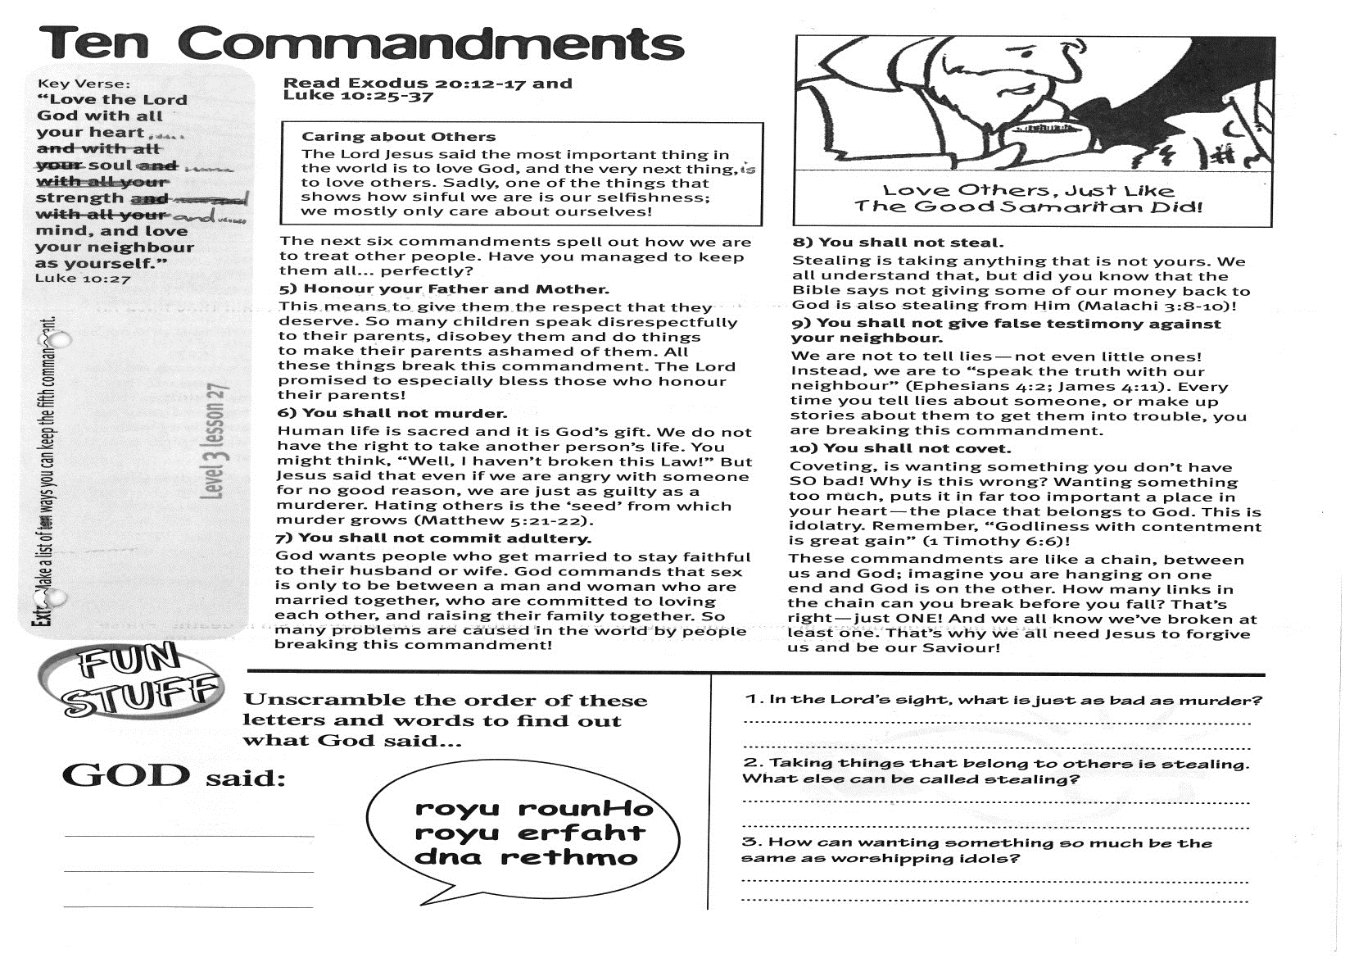

1. Why is the Lord Jesus greater than other famous people in history?

………………………………………………………………………………………………………………………………………………………………………………………………………………………………………………………………

2. How do we know that the Lord Jesus rose from the dead?

………………………………………………………………………………………………………………………………………………………………………………………………………………………………………………………………

**See if you can solve this puzzle:  
(All the words can be found on this page)**

**Level 3 lesson 43**

**Extra:** Can you think of any proof that Jesus is alive?

**God Can Save Us!** We also read in the Bible that because God raised the Lord Jesus, He’ll definitely raise from the dead those who follow Him. No-one who loves and trusts in the Lord Jesus will die forever - they will be raised to life again too, just as Jesus was! That’s why today’s Key Verse talks about a “living hope” - it’s talking about how sure Christians can be that they will live in Heaven with Jesus forever!

Christmas is nearly here, and as we’ve been seeing, it’s about more than just holidays and presents. Don’t be fooled by the pictures of the Lord Jesus as a little baby on Christmas cards. He’s not just another famous person who lived long ago. At Christmas we can remember that the Lord Jesus is alive today as the Saviour of sinners, and through God’s awesome power, He can save you, too!

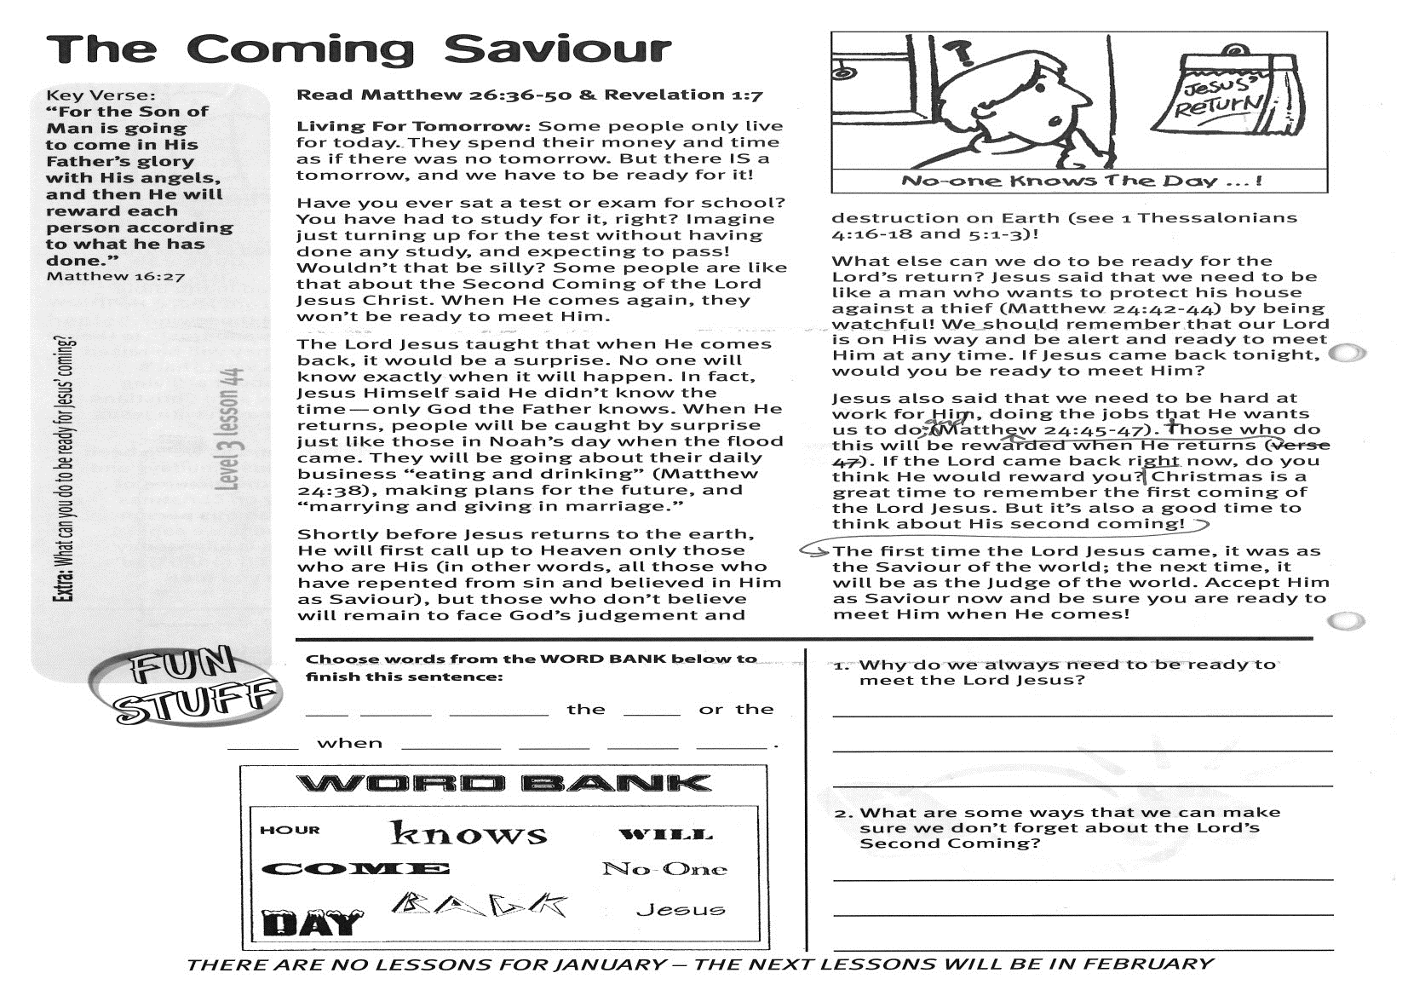

**Read: Matthew 26:36-50   
and Revelation 1:7**

**Living For Tomorrow:** Some people only live for today. They spend their money and time as if there was no tomorrow. But there IS a tomorrow, and we have to be ready for it!

Have you ever sat a test or exam for school? You have had to study for it, right? Imagine just turning up for the test without having done any study, and expecting to pass! Wouldn’t that be silly? Some people are like that about the Second Coming of the Lord Jesus Christ. When He comes again, they won’t be ready to meet Him.

The Lord Jesus taught that when He comes back, it would be a surprise. No-one will know exactly when it will happen. In fact, Jesus Himself said He didn’t know the time - only God the Father knows. When He returns, people will be caught by surprise just like those in Noah’s day when the flood came. They will be going about their daily business “eating and drinking” (Matthew 24:38), making plans for the future, and “marrying and giving in marriage.”

Shortly before Jesus returns to the earth, He will first call up to Heaven only those who are His (in other words, all those who have repented from sin and believed in Him as Saviour); but those who don’t believe will remain to face God’s judgement and destruction on earth!  
(see 1 Thessalonians 4:16-18 and 5:1-3)

Key Verse:  
**“For the Son of Man is going to come in His Father’s glory with His angels, and then He will reward each person according to what he has done.”**

Matthew 16:27

**The Coming Saviour**

**Answer:**

What else can we do to be ready for the Lord’s return? Jesus said that we need to be like a man who wants to protect his house against a thief (Matthew 24:42-44) by being watchful! We should remember that our Lord is on His way and be alert and ready to meet Him at any time. If Jesus came back tonight, would you be ready to meet Him?

Jesus also said that we need to be hard at work for Him, doing the jobs that He wants us to do; and those who do this will be rewarded when He returns (Matthew 24:45-47). If the Lord came back right now, do you think He would reward you?

Christmas is a great time to remember the first coming of the Lord Jesus. But it’s also a good time to think about His second coming! The first time the Lord Jesus came, it was as the Saviour of the world; the next time, it will be as the Judge of the world. Accept Him as Saviour now and be sure you are ready to meet Him when He comes!

**Extra:** What can you do to be ready for   
Jesus’ coming?

**Level 3 lesson 44**

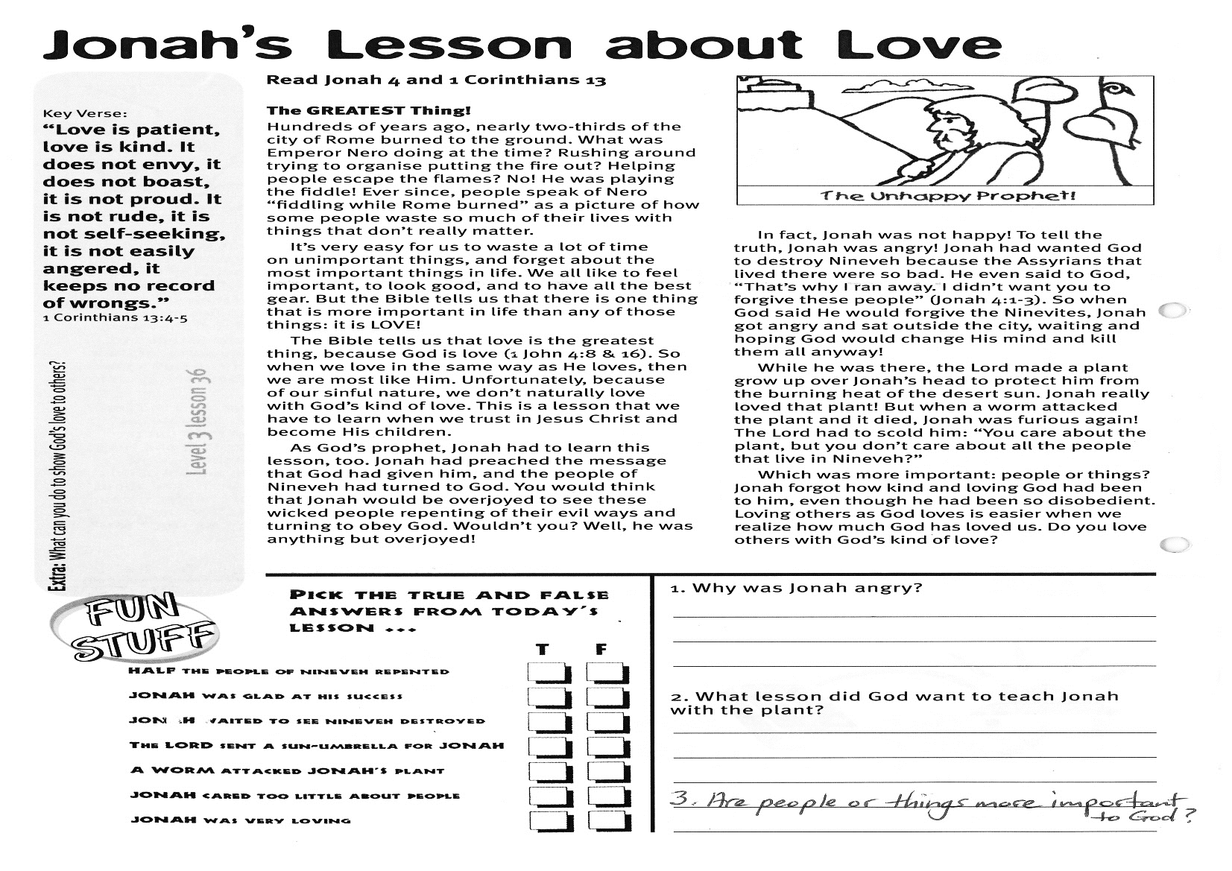

1. Why do we always need to be ready to meet the Lord Jesus?

………………………………………………………………………………  
………………………………………………………………………………………………………………………………………………………………

2. What are some ways that we can make sure we don’t forget about the Lord’s second coming ?

………………………………………………………………………………………………………………………………………………………………

**Choose words from the WORD BANK below to finish this sentence:**

___ ______ _________ the _____ or the _______ when _____ _______ _________ ______ ______ ______



Please complete and return by post to   
**PSSM Bible Discovery, 5/399 New North Rd, Kingsland, Auckland 1021** or scan & email to **info@biblediscovery.org.nz**

**PLEASE NOTE: THERE ARE NO LESSONS IN JANUARY – THE NEXT ONES WILL BE FEBRUARY 2018**