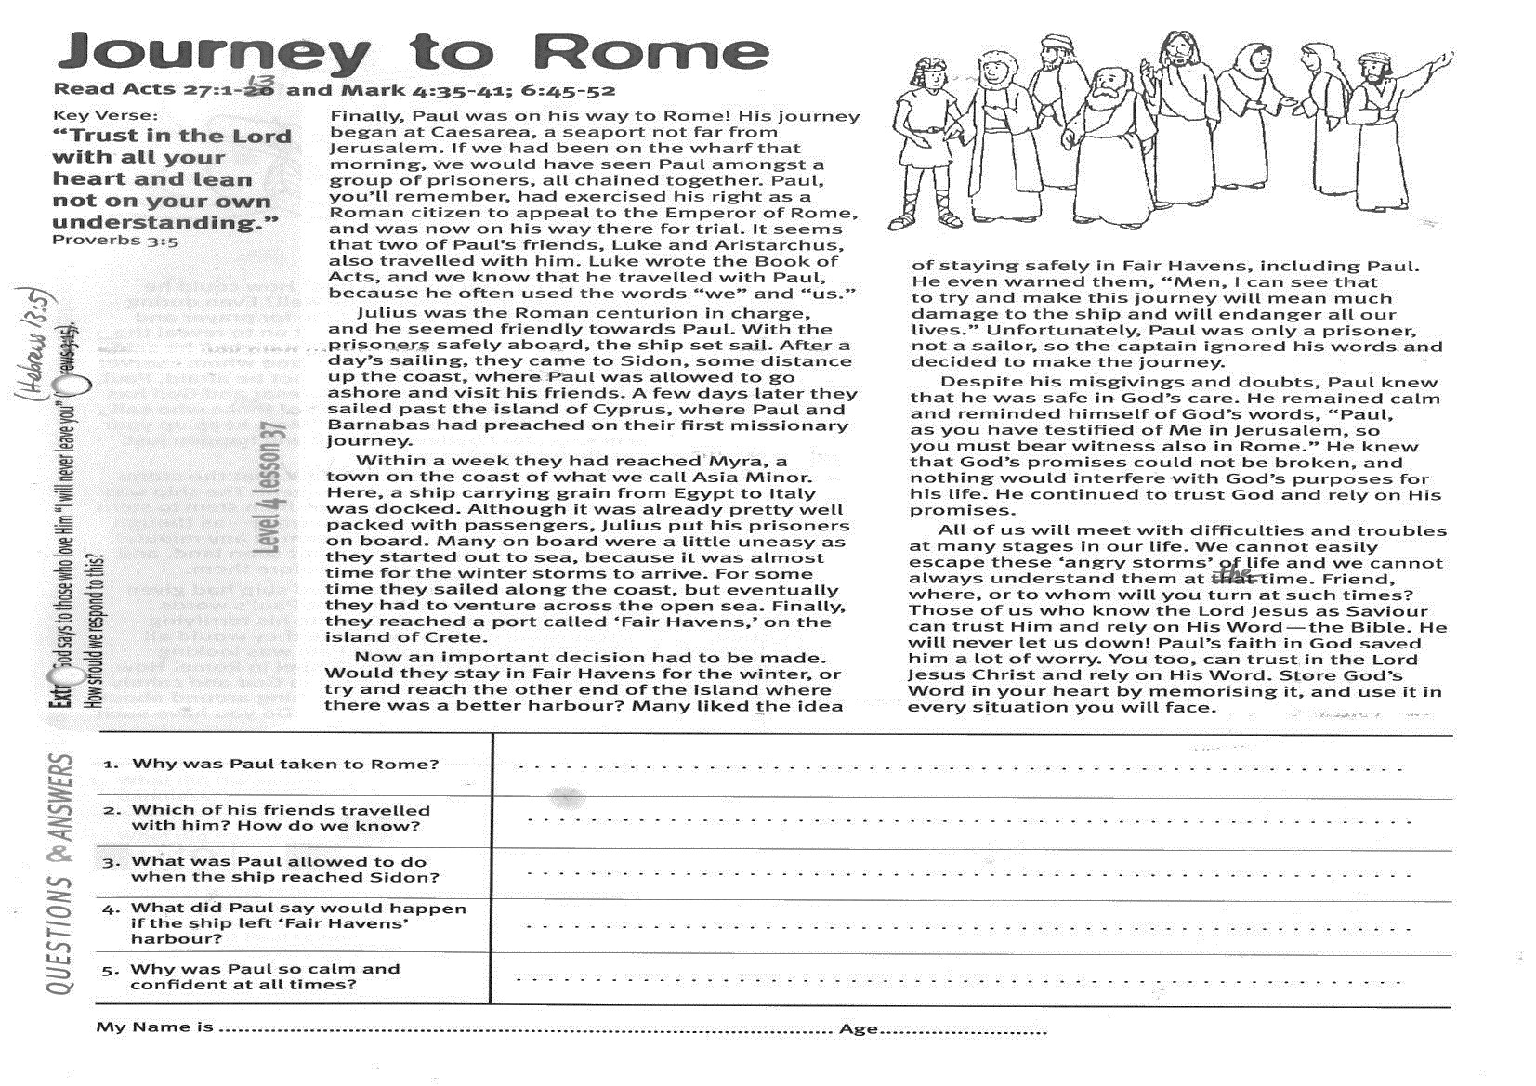
Journey to Rome
Key Verse:
“Trust in the Lord with all your heart and lean not on your own understanding.”
Proverbs 3:5

Read Acts 27:1-13
and Mark 4:35-41; 6:45-52
Finally, Paul was on his way to Rome! His journey began at Caesarea, a seaport not far from Jerusalem. If we had been on the wharf that morning, we would have seen Paul amongst a group of prisoners, all chained together. Paul, you’ll remember, had exercised his right as a Roman citizen to appeal to the Emperor of Rome, and was now on his way there for trial. It seems that two of Paul’s friends, Luke and Aristarchus, also travelled with him. Luke wrote the Book of Acts, and we know that he travelled with Paul, because he often used the words “we” and “us.”
Julius was the Roman centurion in charge, and he seemed friendly towards Paul. With the prisoners safely aboard, the ship set sail. After a day’s sailing, they came to Sidon, some distance up the coast, where Paul was allowed to go ashore and visit his friends. A few days later they sailed past the island of Cyprus, where Paul and Barnabas had preached on their first missionary journey.
Within a week they had reached Myra, a town on the coast of what we call Asia Minor. Here, a ship carrying grain from Egypt to Italy was docked. Although it was already pretty well packed with passengers, Julius put his prisoners on board. Many on board were a little uneasy as they started out to sea, because it was almost time for the winter storms to arrive. For some time they sailed along the coast, but eventually they had to venture across the open sea. Finally, they reached a port called ‘Fair Havens,’ on the island of Crete.
1. Why was Paul taken to Rome?
2. Which of his friends travelled with him? How do we know?
3. What was Paul allowed to do when the ship reached Sidon?
4. What did Paul say would happen if the ship left ‘Fair Havens’ harbour?
5. Why was Paul so calm and confident at all times?
My Name is _____________________________________________ Age ___________
Extra: God says to those who love Him, “I will never leave you” (Hebrews 13:5). How should we respond to this?
Level 4 lesson 37
QUESTIONS & ANSWERS
Level 3 lesson 1
Now an important decision had to be made. Would they stay in Fair Havens for the winter, or try and reach the other end of the island where there was a better harbour? Many liked the idea of staying safely in Fair Havens, including Paul. He even warned them, “Men, I can see that to try and make this journey will mean much damage to the ship and will endanger all our lives.” Unfortunately, Paul was only a prisoner, not a sailor, so the captain ignored his words and decided to make the journey.
Despite his misgivings and doubts, Paul knew that he was safe in God’s care. He remained calm and reminded himself of God’s words, “Paul, as you have testified of Me in Jerusalem, so you must bear witness also in Rome.” He knew that God’s promises could not be broken, and nothing would interfere with God’s purposes for his life. He continued to trust God and rely on His promises.
All of us will meet with difficulties and troubles at many stages in our life. We cannot easily escape these ‘angry storms’ of life and we cannot always understand them at the time. Friend, where, or to whom will you turn at such times? Those of us who know the Lord Jesus as Saviour can trust Him and rely on His Word—the Bible. He will never let us down! Paul’s faith in God saved him a lot of worry. You too, can trust in the Lord Jesus Christ and rely on His Word. Store God’s Word in your heart by memorising it, and use it in every situation you will face.
Key Verse:
“Jesus said, ‘I tell you the truth, unless a man is born again, he cannot see the kingdom of God.’”
John 3:3
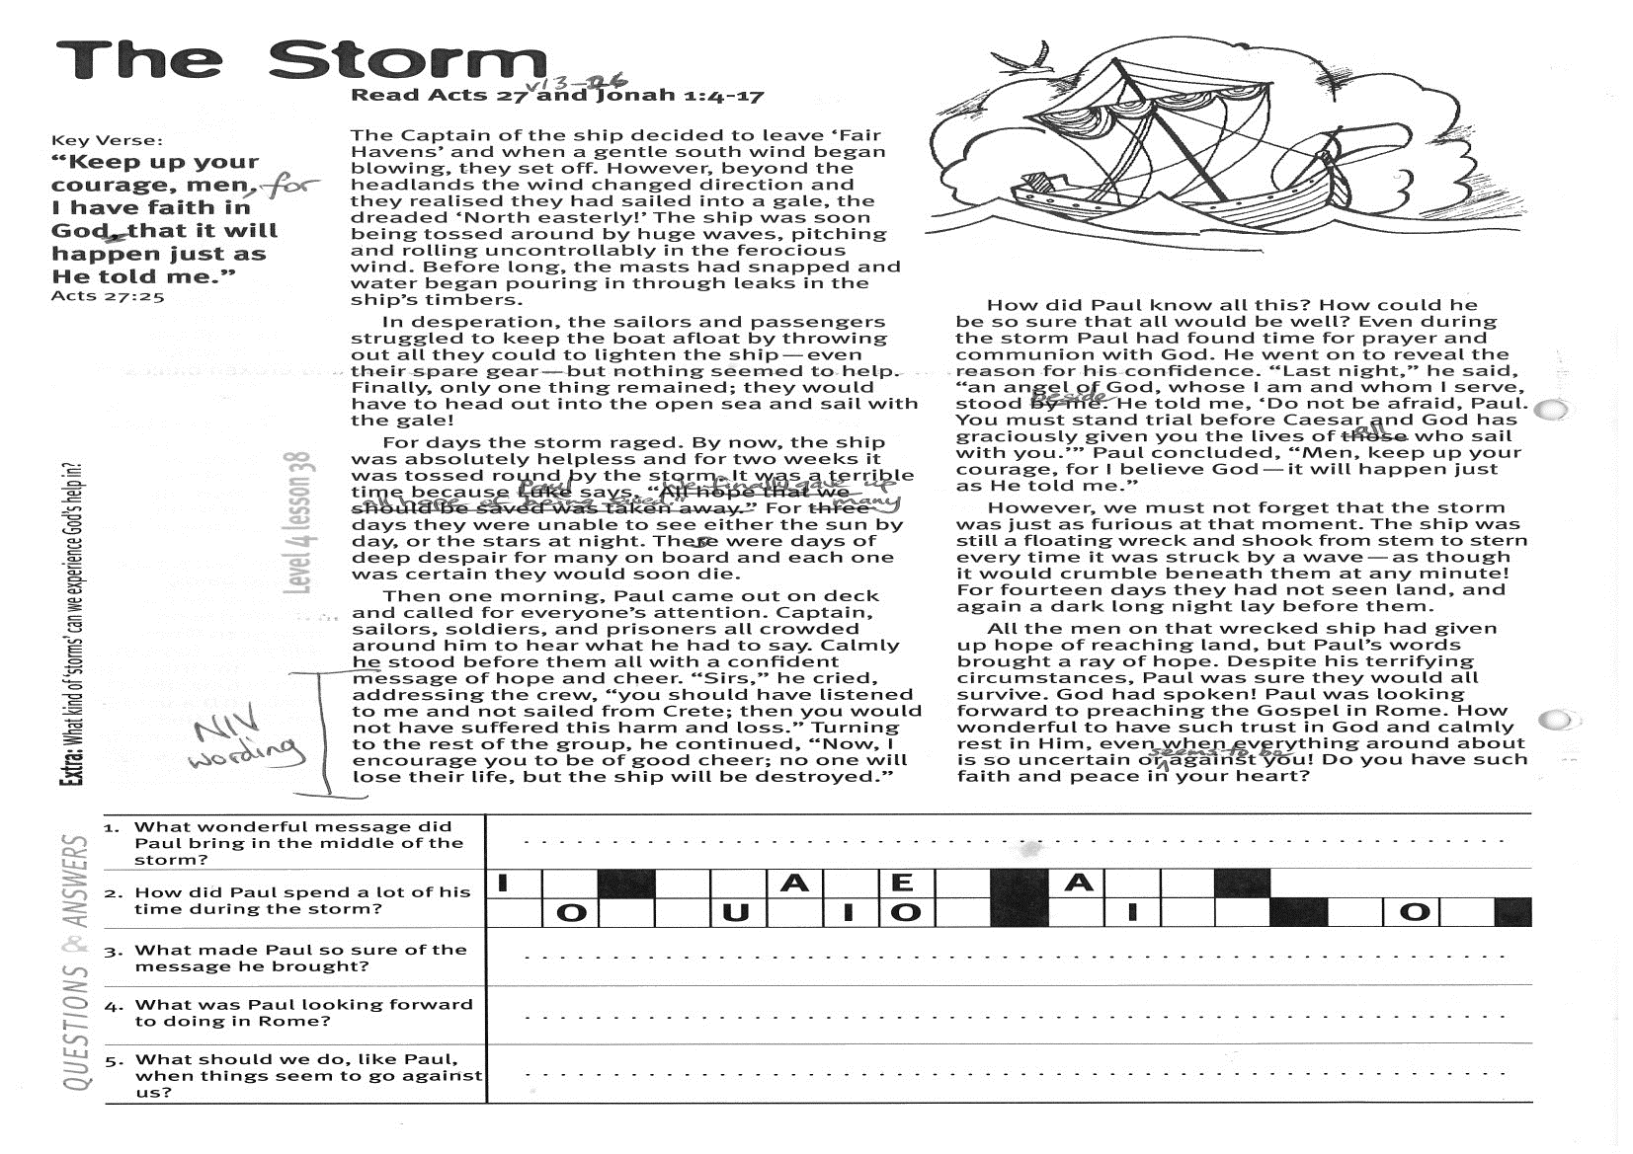
The Storm
Key Verse:
“Keep up your courage, men, for I have faith in God that it will happen just as He told me.”
Acts 27:25
1. What wonderful message did Paul bring in the middle of the storm?
2. How did Paul spend a lot of his time during the storm? | I__ __ __ A __ Y __ __ A __ __ __ O __ __ U __ I O __ __ I __ __ __ O __
3. What made Paul so sure of the message he brought?
4. What was Paul looking forward to doing in Rome?
5. What should we do, like Paul, when things seem to go against us?
Extra: What kind of ‘storms’ can we experience God’s help in?
Level 4 lesson 38
QUESTIONS & ANSWERS
Read Acts 27:13-26
and Jonah 1:4-17
The Captain of the ship decided to leave ‘Fair Havens’ and when a gentle south wind began blowing, they set off. However, beyond the headlands the wind changed direction and they realised they had sailed into a gale, the dreaded ‘North easterly!’ The ship was soon being tossed around by huge waves, pitching and rolling uncontrollably in the ferocious wind. Before long, the masts had snapped and water began pouring in through leaks in the ship’s timbers.
In desperation, the sailors and passengers struggled to keep the boat afloat by throwing out all they could to lighten the ship—even their spare gear—but nothing seemed to help. Finally, only one thing remained; they would have to head out into the open sea and sail with the gale!
For days the storm raged. By now, the ship was absolutely helpless and for two weeks it was tossed round by the storm. It was a terrible time because Luke says, “We finally gave up all hope of being saved.” For three days they were unable to see either the sun by day or the stars at night. These were days of deep despair for many on board and each one was certain they would soon die.
Then one morning, Paul came out on deck and called for everyone’s attention. Captain, sailors, soldiers, and prisoners all crowded around him to hear what he had to say. Calmly he stood before them all with a confident message of hope and cheer. “Men,” he cried, addressing the crew, “you should have taken my advice not to sail from Crete; then you would have spared yourselves this damage and loss.”
Turning to the rest of the group, he continued, “But now I urge you to keep up your courage, because not one of you will be lost; only the ship will be destroyed.”
How did Paul know all this? How could he be so sure that all would be well? Even during the storm Paul had found time for prayer and communion with God. He went on to reveal the reason for his confidence. “Last night,” he said, “an angel of God, whose I am and whom I serve, stood beside me. He told me, ‘Do not be afraid, Paul. You must stand trial before Caesar and God has graciously given you the lives of all who sail with you.’” Paul concluded, “Men, keep up your courage, for I believe God—it will happen just as He told me.”
However, we must not forget that the storm was just as furious at that moment. The ship was still a floating wreck and shook from stem to stern every time it was struck by a wave—as though it would crumble beneath them at any minute! For fourteen days they had not seen land, and again a dark long night lay before them.
All the men on that wrecked ship had given up hope of reaching land, but Paul’s words brought a ray of hope. Despite his terrifying circumstances, Paul was sure they would all survive. God had spoken! Paul was looking forward to preaching the Gospel in Rome. How wonderful to have such trust in God and calmly rest in Him, even when everything around about is so uncertain or seems to be against you! Do you have such faith and peace in your heart?

QUESTIONS:

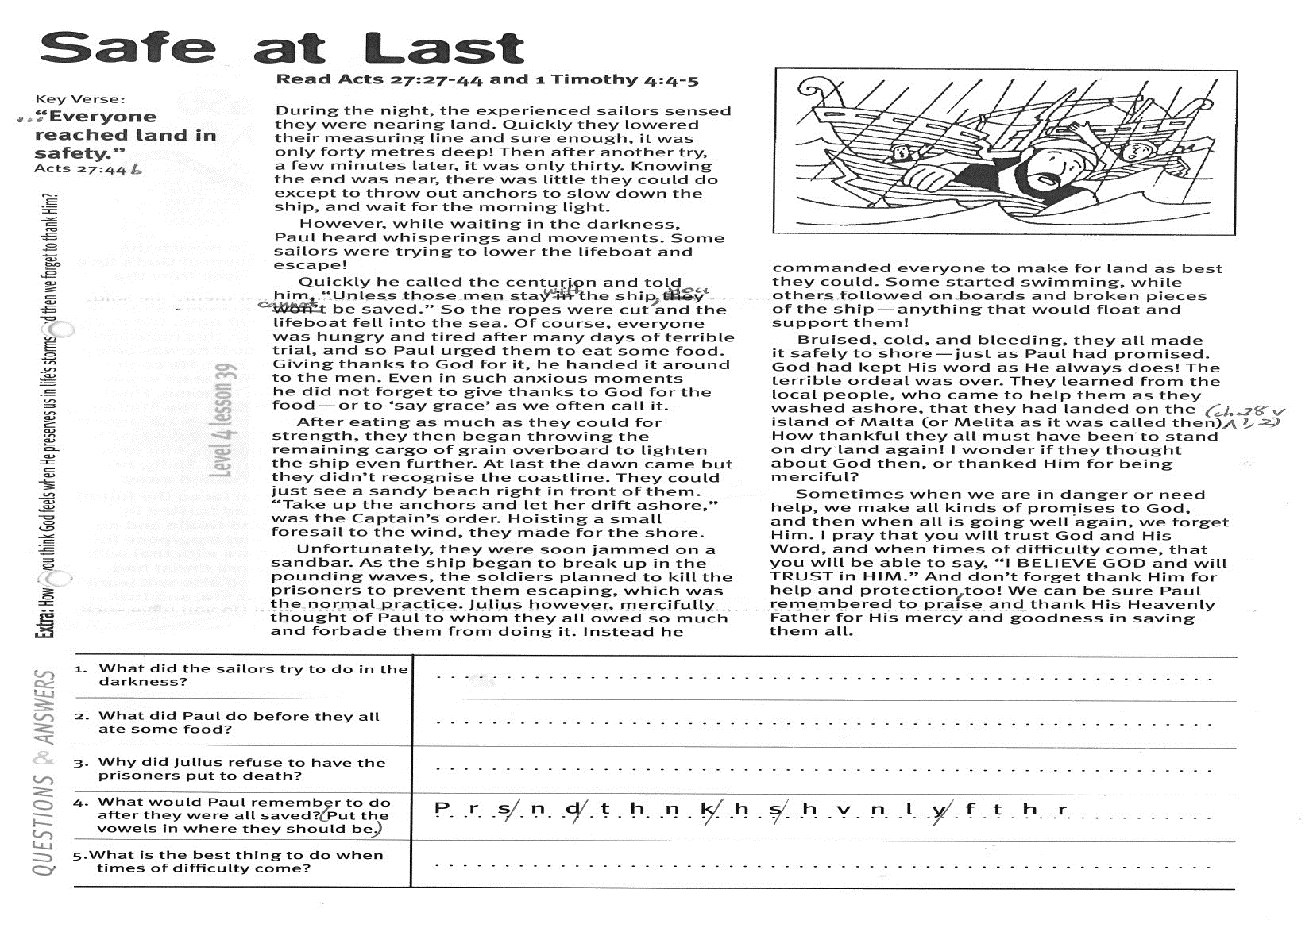
Key Verse:
“…everyone reached land in safety.”
Acts 27:44b
Read Acts 27:27-44
and 1 Timothy 4:4-5
During the night, the experienced sailors sensed they were nearing land. Quickly they lowered their measuring line and sure enough, it was only forty metres deep! Then after another try, a few minutes later, it was only thirty. Knowing the end was near, there was little they could do except to throw out anchors to slow down the ship, and wait for the morning light.
However, while waiting in the darkness, Paul heard whisperings and movements. Some sailors were trying to lower the lifeboat and escape!
Quickly he called the centurion and told him, “Unless those men stay with the ship, you cannot be saved.” So the ropes were cut and the lifeboat fell into the sea. Of course, everyone was hungry and tired after many days of terrible trial, and so Paul urged them to eat some food. Giving thanks to God for it, he handed it around to the men. Even in such anxious moments he did not forget to give thanks to God for the food—or to ‘say grace’ as we often call it.
After eating as much as they could for strength, they then began throwing the remaining cargo of grain overboard to lighten the ship even further. At last the dawn came but they didn’t recognise the coastline. They could just see a sandy beach right in front of them. “Take up the anchors and let her drift ashore,” was the Captain’s order. Hoisting a small foresail to the wind, they made for the shore.
Unfortunately, they were soon jammed on a sandbar. As the ship began to break up in the pounding waves, the soldiers planned to kill the prisoners to prevent them escaping, which was the normal practice. Julius however, mercifully thought of Paul to whom they all owed so much and forbade them from doing it.

Safe at Last
1. What did the sailors try to do in the darkness?
2. What did Paul do before they all ate some food?

3. Why did Julius refuse to have the prisoners put to death?
4. What would Paul remember to do after they were all saved? (Add the vowels) | P r s n d t h n k h s h v n l y f t h r
5. What is the best thing to do when times of difficulty come?
Extra: How do you think God feels when He preserves us in life’s storms, and then we forget to thank Him?

Level 4 lesson 39
QUESTIONS & ANSWERS
Instead he commanded everyone to make for land as best they could. Some started swimming, while others followed on boards and broken pieces of the ship—anything that would float and support them!
Bruised, cold, and bleeding, they all made it safely to shore—just as Paul had promised. God had kept His word as He always does! The terrible ordeal was over.
They learned from the local people, who came to help them as they washed ashore, that they had landed on the island of Malta (or Melita as it was called then). How thankful they all must have been to stand on dry land again! I wonder if they thought about God then, or thanked Him for being merciful?
Sometimes when we are in danger or need help, we make all kinds of promises to God, and then when all is going well again, we forget Him. I pray that you will trust God and His Word, and when times of difficulty come, that you will be able to say, “I BELIEVE GOD and will TRUST in HIM.” And don’t forget to thank Him for help and protection, too!
We can be sure Paul remembered to praise and thank His Heavenly Father for His mercy and goodness in saving them all.

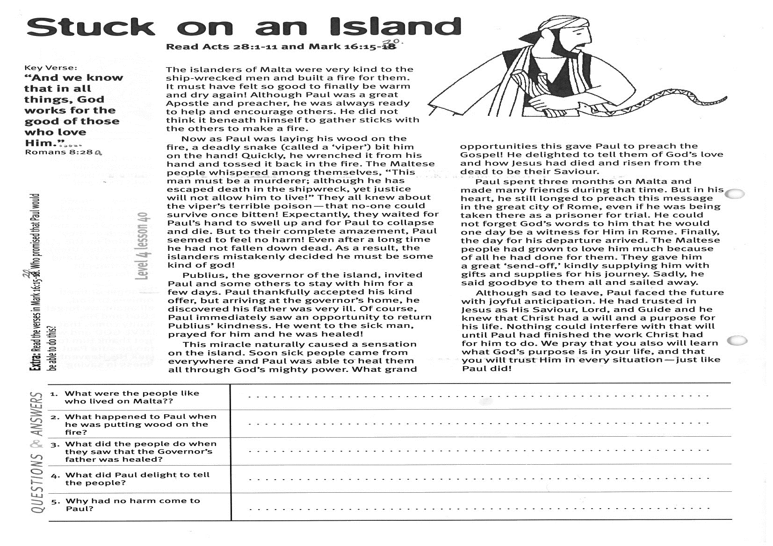
Stuck on an Island
Key Verse:
“And we know that in all things, God works for the good of those who love Him…”
Romans 8:28a
Read Acts 28:1-11
and Mark 16:15-20
The islanders of Malta were very kind to the ship-wrecked men and built a fire for them. It must have felt so good to finally be warm and dry again! Although Paul was a great Apostle and preacher, he was always ready to help and encourage others. He did not think it beneath himself to gather sticks with the others to make a fire.
Now as Paul was laying his wood on the fire, a deadly snake (called a ‘viper’) bit him on the hand! Quickly, he wrenched it from his hand and tossed it back in the fire. The Maltese people whispered among themselves, “This man must be a murderer; although he has escaped death in the shipwreck, yet justice will not allow him to live!” They all knew about the viper’s terrible poison—that no-one could survive once bitten!
Expectantly, they waited for Paul’s hand to swell up and for Paul to collapse and die. But to their complete amazement, Paul seemed to feel no harm! Even after a long time he had not fallen down dead. As a result, the islanders mistakenly decided he must be some kind of god!
Publius, the Governor of the island, invited Paul and some others to stay with him for a few days. Paul thankfully accepted his kind offer, but arriving at the Governor’s home, he discovered his father was very ill. Of course, Paul immediately saw an opportunity to return Publius’ kindness. He went to the sick man, prayed for him and he was healed!

1. What were the people like who lived on Malta?
2. What happened to Paul when he was putting wood on the fire?
3. What did the people do when they saw that the Governor’s father was healed?

4. What did Paul delight to tell the people?

5. Why had no harm come to Paul?
Extra: Read the verses in Mark 16:15-20. Who promised that Paul would be able to do this?
Level 4 lesson 40
QUESTIONS & ANSWERS
This miracle naturally caused a sensation on the island. Soon sick people came from everywhere and Paul was able to heal them all through God’s mighty power. What grand opportunities this gave Paul to preach the Gospel! He delighted to tell them of God’s love and how Jesus had died and risen from the dead to be their Saviour.
Paul spent three months on Malta and made many friends during that time. But in his heart, he still longed to preach this message in the great city of Rome, even if he was being taken there as a prisoner for trial. He could not forget God’s words to him that he would one day be a witness for Him in Rome. Finally, the day for his departure arrived.
The Maltese people had grown to love him much because of all he had done for them. They gave him a great ‘send-off,’ kindly supplying him with gifts and supplies for his journey. Sadly, he said goodbye to them all and sailed away.
Although sad to leave, Paul faced the future with joyful anticipation. He had trusted in Jesus as His Saviour, Lord, and Guide and he knew that Christ had a will and a purpose for his life. Nothing could interfere with that will until Paul had finished the work Christ had for him to do.
We pray that you also will learn what God’s purpose is in your life, and that you will trust Him in every situation—just like Paul did!
Please complete and return by post to
PSSM Bible Discovery, 5/399 New North Rd, Kingsland, Auckland 1021 or scan & email to info@biblediscovery.org.nz

