**November 2017  
Bible Readings**

DATE BOOK REFERENCE

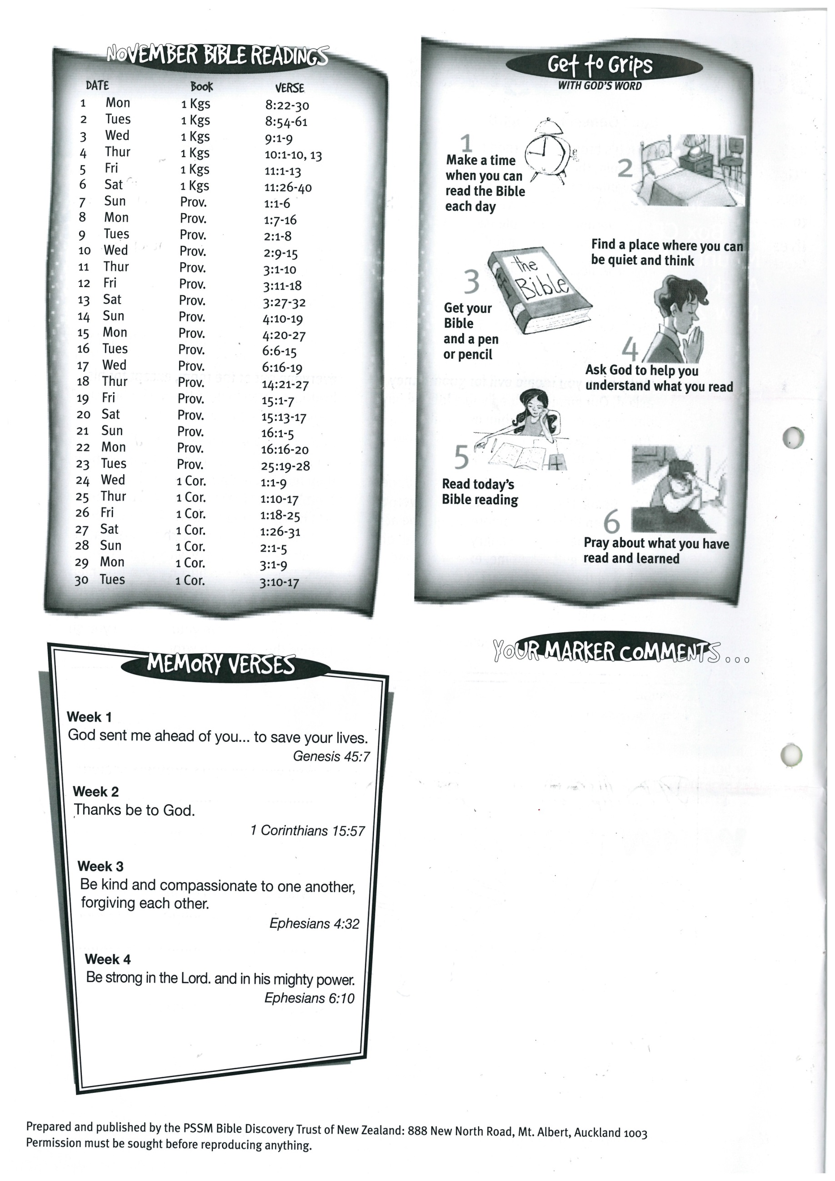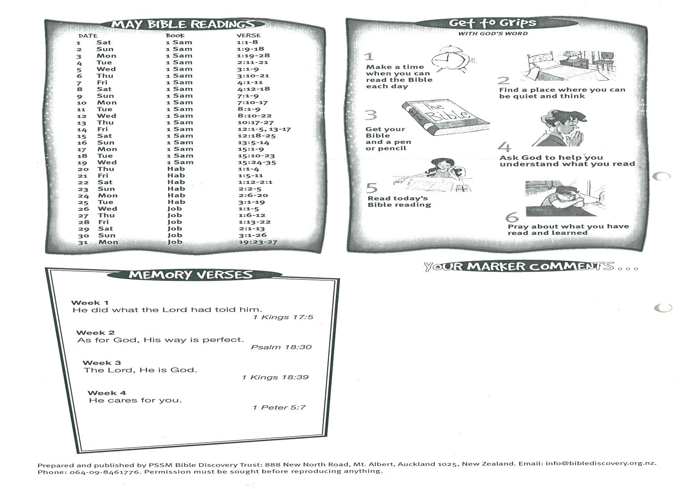



**1 Cor. 3:10-17**

**29  
30 Luke 10:38-42  
31 Luke 7:18-23**